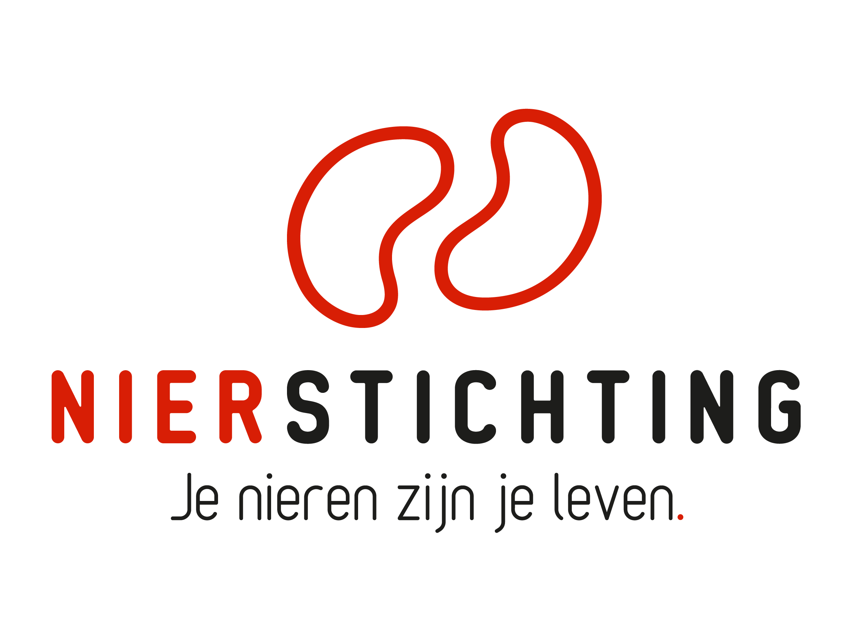
Dutch Kidney Foundation
Application form
Kolff+ Program
16 January 2024

The Dutch Kidney Foundation (DKF) General Grant Requirements (Subsidievoorwaarden Nierstichting Nederland) apply to all awarded DKF subsidies as well as all proposals for DKF subsidies. Applicability of general and other conditions of the applicant, the applicant's institute and of third parties is explicitly excluded.

Disclaimer
The execution of a DKF Call for proposals, selection of pre-proposals for full application and positive DKF grant award decisions are conditional on DKF revenues and budgetary means. The DKF explicitly reserves the right to cancel an initiated Call for proposals, to suspend a running procedure or to lower a grant amount in relation to earlier statements.

Nierstichting / Dutch Kidney Foundation
+31 (0)35 697 8015
research@nierstichting.nl

Instructions for completing and submitting this form
The submitted proposal must meet the following conditions for acceptance in this call:
- Forms should be filled in using Arial 10 pt.
- Maximum word counts specified are fixed limits that must not be exceeded. Please fill in the number of words used where asked.
- Images (figures, tables, etc.) can be added and must each have a readable format and size. All images taken together must not exceed 2 pages and any words used in the images or image description will count towards the maximum word count of the section in which they are used.
- You are not allowed to insert (hyper)links.
- References are only allowed in sections that specifically ask for references.
- Please note that the section Patient Perspective should be completed in Dutch.
- Instructions and/or sections in the form must not be deleted (even if the section is not applicable), unless you are instructed otherwise.
- Please save the completed application form, including electronic signatures, in a searchable PDF file (scans of printed documents are not accepted). Upload the saved PDF file into your digital submission form in our grant management system called MIDAS via this link. The maximum file size is 5 MB. Attachments are not accepted.

After completing this form, please carefully check if your answers comply with all our instructions and conditions.

- Project
Title
Acronym (optional)
Duration in months
Proposed DKF budget

- Type of Kolff+ Grant
Please select the type of Kolff+ grant you apply for (only one answer is possible):
☐ Creativity Grant
☐ Junior Talent Grant
☐ Senior Talent Grant
☐ Success Accelerator Grant
- Applicant
Name
Institute, Department
Room number
PO Box (postbus)
Postal code, Town/City
Phone
Email
Researcher Identification
(e.g. ResearcherID, ORCID)

- Planning
Expected start date
Expected end date
Duration in months

5. Sections
- General Information
- Grant Specific Information
- Description
- Patient Perspective (in Dutch)
- Funding
- Signatures

- General information

- Abstract (Creativity Grant max. 500 words; Talent and Success grants max. 750 words)
Number of words used:
Note: The text provided in this item should be copied and pasted into the digital submission form in MIDAS, after removing references to literature lists, to figures or to tables (the text will be sent to potential reviewers, without further additions, and therefore it should be a stand-alone document).

Please address the following points:
- Central problem you address with your proposal.
- Rationale of your proposal for solving the problem.
- Central hypothesis and aims / objectives.
- Methodology and motivation of the choice of methodology.
- A concise description of the workplan.
- Expected deliverables of the overall project.

- Applicant - CV
Education
PhD | Thesis title
 | University
 | Supervisor
 | (Planned) graduation date
MD (Medical Doctor degree) | Subject
 | University
 | (Planned) graduation date
Medical specialism | Subject
 | (Planned) registration date
Current position

- Applicant - Employment Record (max. 200 words)
Number of words used:

- Applicant - Acquired Research Grants (max. 250 words)
Number of words used:

- Partners and participants in the project (max. 10)
Please provide the names and affiliations of all funded and non-funded participants in the project. Participants can be asked for their acknowledgement.

Institute | Department | Name | Function | Expertise and role in the project | Funding source | Fte

- Broad Strategy (max. 100 words)
Number of words used:

- How does the project fit in with "Nierziekte de baas", the joint Dutch renal strategic agenda for innovation and research? (In English "Beating kidney disease".)
- How does the project fit in with the missions of the "Kennis- en Innovatieagenda 2020-2023 Gezondheid en Zorg"?

- GRANT SPECIFIC INFORMATION

1. Type of Kolff+ Grant
Please select the type of Kolff+ grant you apply for (only one answer is possible):
☐ Creativity Grant à answer question 2, the other questions from this section can be removed
☐ Junior Talent Grant à answer question 3, the other questions from this section can be removed
☐ Senior Talent Grant à answer question 4, the other questions from this section can be removed
☐ Success Accelerator Grant à answer question 5, the other questions from this section can be removed

Creativity Grant (max. 500 words)
Number of words used:
Use your answer from the pre-application. Update and refine where needed.

Please address the following points:
- Why do you apply for a Creativity Grant?
- Show why your idea for this proposal is creative and original. Elements of creativity are for instance independent thinking and using the imagination, novelty, unusual and outside-the-box concepts, resourcefulness and inventiveness.
- Show how your proposal fits the innovation profile of a high risk hypothesis with a high gain in potential impact.
- Show how you will advance the results of your project, if successful, towards impact for patients.

Junior Talent Grant (max. 750 words)
Number of words used:
Use your answer from the pre-application. Update and refine where needed.

Show how your profile fits a Junior Talent Grant career phase. Give a short description of your employment record and your research track: research experience (fte) after graduation, summary of previous research and outcome.

In addition, show your motivation and strategy for a career in kidney-related research and for reaching impact for patients. Please address the following points:
- What is your motivation for pursuing a career in kidney-related research?
- How will you develop your multidisciplinary network? Also consider relevant areas outside research.
- Give a short description of the research line you want to set off in this project. Explain your strategy towards impact for patients and show how your research line and the proposal fit within this strategy.
- What are your goals in five years, what position in kidney-related research and what impact for patients do you want to achieve? What is your personal strategy towards playing an important role in kidney-related research?

Senior Talent Grant (max. 750 words)
Number of words used:
Use your answer from the pre-application. Update and refine where needed.

Show how your profile fits a Senior Talent Grant career phase. Give a short description of your employment record and your research track: research experience (fte) after graduation, summary of previous research and outcome.

Show your motivation and strategy for a career in kidney-related research and for reaching impact for patients. Please address the following points:
- What is your motivation for pursuing a career in kidney-related research?
- How will you further develop your multidisciplinary network? Also consider relevant areas outside research.
- Give a short description of the research line you want to follow up in this project. Explain your strategy towards impact for patients and show how your research line and the proposal are embedded within this strategy.
- What are your goals in ten years, what position in kidney-related research and what impact for patients do you want to achieve? What is your personal strategy towards playing an important role in kidney-related research?

Success Accelerator Grant (max. 750 + 250 words)
Number of words used:
Use your answer from the pre-application. Update and refine where needed. Note the added item in the point list below.

Please address the following points:
- Why do you apply for a Success Accelerator Grant?
- Give a short description of your research group / line strategy towards impact for patients.
- Show how your proposal follows up on successful research and how this advances your research line in the direction of impact for patients.
- Show how your proposal is embedded within the strategy of your research group / line and how it can further advance success in the direction of impact for patients.
- Give a clear and concrete description of your plan for further development of project results and stakeholder collaboration towards impact.

- Description

1. Hypothesis, Aims and Objectives (max. 200 words)
Number of words used:

2. Subject Review
(Creativity Grant max. 375 words; Talent and Success grants max. 750 words)
Number of words used:
Describe the current knowledge regarding the central problem that is addressed in the project plan. Provide sound corroboration of the project rationale and the proposed solution to the problem.

3. Key References
(Creativity Grant max. 10; Talent and Success grants max. 20)
- Provide the ten / twenty most important references here.
- Provide only references in this item.
- Do not add references to the other items in this section.

4. Work Plan
(Creativity Grant: whole project, max. 1000 words;
Talent and Success grants: detailed first half of the project & summary second half, max. 1500 words)
Number of words used:
Provide a concrete and elaborate description of the work plan of the first half of the project and describe the steps/deliverables that will be taken to achieve the aims of the project.

- Risk Factors (max. 300 words)
Number of words used:
Possible risk factors that may limit the feasibility of the project. Indicate how the risks will be addressed.

- Human Studies (if applicable, max. 400 words)
Number of words used:
Please address all of the following points or motivate why not relevant:
- Target group. Numbers of participants (patients and controls) required and numbers of subjects to be approached.
- Power calculation.
- Efforts required from participants (patients and controls) and possible risks of study participation.
- Inclusion strategy. Inclusion problems are common in clinical studies and have special attention of the DKF. What are possible obstacles for inclusion and which safeguards are taken? What are possible solutions if problems arise?
- Procedures (e.g. randomisation, blinding).
- Describe the arrangements with organisations and persons (not funded by this project) whose cooperation is necessary for successful inclusion and execution of the study.
- Timeline for the “METC” (Ethical Review Committee) procedure.

More information: 1) DCRF toolkit to improve study participation in research.

- Animal Studies (if applicable, max. 400 words)
Number of words used:
Please address all of the following points or motivate why not relevant:
- Motivate the approach using animal studies to address the project’s problem rather than other research methods (e.g. in vitro studies using cells or cell lines, organoids, computer simulation).
- Choice of models. Motivate the models that are available and relevant for the project.
- Describe why and how the proposed models are representative for human physiology and disease.
- Procedures (e.g. randomisation, blinding).
- Motivate the numbers of animals required. Provide a power calculation.
- Timeline for the "DEC" (Animal Research Ethical Committee) procedure.

- Time Schedule and Deliverables
(Creativity Grant max. 200 words; Talent and Success grants max. 300 words)
Number of words used:
Provide a concise description of the timeline based on the aforementioned work plan and steps/deliverables. Use a Gantt chart if possible.

- Patiëntenperspectief
Note for international reviewers: this section is in Dutch and will be reviewed by a patient panel. International reviewers do not review this section.

Deze sectie van het aanvraagformulier is bedoeld voor de beoordeling vanuit het patiëntenperspectief door patiënt-beoordelaars van de Nierpatiënten Vereniging Nederland. Deze sectie moet de patiënt-beoordelaars helder inzicht geven in alle aspecten van de aanvraag. De tekst moet begrijpelijk zijn voor mensen die niet werkzaam zijn in de wetenschap zonder belangrijke details achterwege te laten. Deze sectie graag invullen in het Nederlands. Nota bene, de term patiënten kan ook betrekking hebben op donoren of naasten. Een vertegenwoordiger van de groep patiënt-beoordelaars zal aanwezig zijn bij de vergadering van de Wetenschappelijke Raad om het patiëntoordeel toe te lichten.

- Doel en projectbeschrijving (max. 400 woorden)
Aantal gebruikte woorden:
Geef een samenvatting van het voorgestelde project met een probleembeschrijving, de hypothese, het doel en het werkplan.

- Strategie (max. 200 woorden)
Aantal gebruikte woorden:
Dit onderdeel is verplicht voor de Succes Beurs en de Talent beurzen en optioneel voor de Creativity beurs.
Beschrijf de volgende punten:
- Het groter geheel en hoe dit onderzoek hieraan gaat bijdragen
- De benodigde samenwerking(en) en hoe deze essentieel is/zijn om het doel van het voorgestelde project te bereiken

- Relevantie (directe of indirecte bijdrage aan het oplossen van de behoeften van patiënten) (max. 200 woorden)
Aantal gebruikte woorden:
Beantwoord de volgende punten of motiveer waarom ze niet relevant zijn.
a. Beschrijf op welke manier het onderzoek:
- Aansluit bij behoeften van huidige en toekomstige patiënten
- Direct of indirect bijdraagt aan de verbetering van gezondheid
- Direct of indirect bijdraagt aan kwaliteit van leven, zelfredzaamheid en maatschappelijke participatie
- Direct of indirect bijdraagt aan de zorg in het algemeen
b. Benoem de uitkomstmaten op patiëntniveau (bijv. gezondheid, kwaliteit van leven, zelfstandigheid. Denk aan Patient Reported Outcome Measures [PROMs]).

- Innovativiteit en creativiteit (max. 200 woorden)
Aantal gebruikte woorden:
Beantwoord de volgende punten of motiveer waarom ze niet relevant zijn. Dit onderdeel is verplicht voor de Creativiteit Beurs en optioneel voor de Succes Beurs en de Talent beurzen.
a. Geef aan wat dit voorgestelde project innovatief maakt
b. Geef aan wat dit voorgestelde project creatief maakt

- Haalbaarheid en risico’s (max. 200 woorden)
Aantal gebruikte woorden:
Beschrijf de volgende punten:
- In- en exclusiecriteria
- Belasting voor de deelnemers (bijv. ondergaan van de behandeling/diagnostiek, invullen van vragenlijsten, duur van het onderzoek) ten opzichte van de standaard behandeling. Voeg bij voorkeur een flowchart of een tabel toe waarin alle tijdspunten en handelingen staan weergegeven
- Risico’s van deelname aan het onderzoek voor de deelnemers

- Patiëntenparticipatie (anders dan deelnemen aan de studie) (max. 200 woorden)
Aantal gebruikte woorden:
Benoem de betrokkenheid van patiënten (ervaringsdeskundigen) bij het onderzoek. Geef aan in welke fasen de betrokkenheid terug te zien is (bijv. opzet van het projectplan, uitvoering van het onderzoek), en hoe deze wordt gefaciliteerd. Geef details over de ervaringsdeskundigen (bijv. aantal, kenmerken) en hun rol.

Meer informatie: 1) ‘De rol van patiënten in onderzoek’ (NVN); 2) ‘Een 10 voor patiëntenparticipatie’ (ZonMw); 3) ‘Kickstarter voor onderzoekers’ (PGOsupport); 4) secretariaat@nvn.nl of 035-6912128.

- Resultaat en evaluatie patiëntenparticipatie (max. 200 woorden)
Aantal gebruikte woorden:
Beschrijf kort wat het betrekken van ervaringsdeskundigen bij dit projectplan heeft opgeleverd. Benoem en motiveer daarnaast welke suggesties van ervaringsdeskundigen niet verwerkt zijn in het projectplan.

- Informatie, begeleiding en communicatie (max. 200 woorden)
Aantal gebruikte woorden:
a. Geef aan op welke manier deelnemers informatie ontvangen over deelname aan het onderzoek en op welke wijze de begeleiding van deelnemers tijdens het onderzoek geregeld is.
b. Beschrijf op welke manier er terugkoppeling plaatsvindt van resultaten naar de individuele deelnemers.
c. Beschrijf het plan om de resultaten van dit onderzoek landelijk/wereldwijd te verspreiden.

- Funding

- Budget Matrix
Specify the proposed standard personnel years according to the DKF Project Funding Model. You can open the worksheet with a right mouse click > worksheet object > “bewerken”. Please only enter fte and extra budget per year. The worksheet will automatically calculate total fte, budget in euros and total budget. Maximum number of years, total budgets and possibilities for extra budget within the maximum for specific type of Kolff+ Grants are provided in the Kolff+ Information Sheet.

NB:
Personnel: For each PhD student contracted within the project, the employer guarantees a contract for at least 3 years (fulltime, or a proportionally equivalent duration if parttime), also in the case where the requested DKF funding only covers a shorter period.

Extra budget:
For Junior Talent, Senior Talent and Success Accelerator applications: the budget for extra expenses must not exceed 30 percent of the total requested budget. For Creativity applications: the budget for extra expenses must not exceed 60 percent of the total requested budget.

- Motivation for Personnel and Extra Expenses (max. 200 words)
Number of words used:
Give a short description of and motivation for the proposed personnel, consumables and equipment. If applicable, specify the extra budget for fees for patient representatives, equipment and consumables, and for outsourcing technical parts of the project.

- Additional Funding from Other Sources (if applicable, max. 100 words)
Number of words used:
Provide information on (possible) contributions by the applicants’ organisation, partner organisations and third parties. Specify the amount of the in-cash contributions per organisation. When applicable, also provide a separate estimation of (possible) in-kind contributions.

- Supporting Organisations: only those not listed in table I. 5 (max. 100 words)
If applicable, list the organisations (not participating in the project, and therefore not included in table I.5) that will provide essential support to perform this project, e.g. providing research products or knowledge, or contributing to the inclusion of patients. Attachments are not accepted.

- Signatures

 | Name and position | Signature | Date
Applicant

Authorisation
(e.g. Head of Department, Head of Institute, Director)

Do not insert any text or figure above or below this table.

