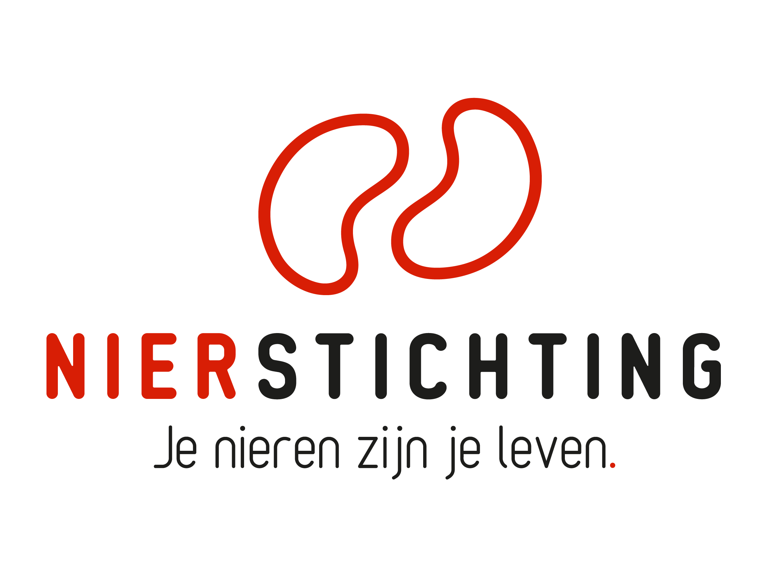
Dutch Kidney Foundation
Pre-application form
Kolff+ Program
Form version: July 2023

The Dutch Kidney Foundation (DKF) General Grant Requirements (Subsidievoorwaarden Nierstichting Nederland) apply to all awarded DKF subsidies as well as all proposals for DKF subsidies. Applicability of general and other conditions of the applicant, the applicant's institute and of third parties is explicitly excluded.

Disclaimer
The execution of a DKF Call for proposals, selection of pre-proposals for full application and positive DKF grant award decisions are conditional on DKF revenues and budgetary means. The DKF explicitly reserves the right to cancel an initiated Call for proposals, to suspend a running procedure or to lower a grant amount in relation to earlier statements.

Nierstichting / Dutch Kidney Foundation
+31 (0)35 697 8015
research@nierstichting.nl

Conditions for completing and submitting this form
Note well that we do not accept applications that do not comply with the conditions for submitting this form.

Every section and item in this form is provided with clear instructions (italicised text). Please read them carefully and make sure your answers are in line with the instructions. As a part of the selection procedure, the pre-applications will be assessed by members of the scientific advisory board (WR). Please take into account their varied expertise. Avoiding too specific technical language and abbreviations will enhance the comprehensibility of your text.

The submitted proposal must meet the following conditions:
- Do not delete or alter the text and instructions of this form. All texts and instructions must be left intact.
- Use Arial 10 pt. filling in this form.
- The maximum word counts are fixed limits. Do not exceed the maximum word count. Please fill in the number of words used where asked.
- If you use images, please only insert them in the abstract and follow the instructions (section I.1). Please only insert references in the item key references (Section I.2).
- The use of tables is allowed and counts towards the word count. Use Arial 10 pt. Do not insert images of tables to bypass the word count.
- You are not allowed to insert (hyper)links.
- Make a searchable PDF file upon completing this application form. We do not accept scans of printed PDF documents.
- Include electronic signatures in the searchable PDF file.
- Upload the saved PDF file into your digital submission form in MIDAS via this link. The maximum file size is 5 MB.
- We do not accept attachments or other documents such as letters of support.

After completing this form, please carefully check if your answers comply with all our instructions and conditions.

1. Project
Title
Acronym (optional)
Duration in months
Proposed DKF budget
Grant type | ☐ Creativity Grant  ☐ Junior Talent Grant  ☐ Senior Talent Grant  ☐ Success Accelerator Grant

2. Applicant
Name (M/F)
Institute, Department
Room number
PO Box (postbus)
Postal code, Town/City
Phone
Email
Researcher Identification
(e.g. ResearcherID, ORCID)

- GENERAL INFORMATION

- Abstract (Creativity Grant max. 500 words; Talent and Success Grant max. 750 words)
Number of words used:

Note: The text provided in this item should be copied and pasted into the digital submission form in MIDAS, after removing references to literature lists, to figures or to tables (the text will be sent to potential reviewers, without further additions, and therefore it should be a stand-alone document).

Please address the following points:
- The problem you address with your proposal.
- Rationale of your proposal for solving the problem.
- The hypothesis and aims / objectives.
- Methodology and motivation of the choice of methodology.
- A concise description of the workplan.
- Expected deliverables.

The use of images is exclusively allowed in this section and must meet the following criteria:
  - Texts in the images have to be readable (Arial 10 pt.)
  - All words used in the images or image description are included in the maximum word count of this section.
  - All images taken together must not exceed 1 page.
  - All images must be clear and readable on a printed A4.

- Key References (max. 12)
- Please provide the twelve most important references here (including references to your own publications, if applicable). Provide only references in this item. Do not add references anywhere else and do not include (hyper)links.

- Applicant CV
Education
PhD | Thesis title
 | University
 | Supervisor
 | (Planned) graduation date
MD (Medical Doctor degree) | Subject
 | University
 | (Planned) graduation date
Medical specialism | Subject
 | (Planned) registration date
Current position
Acquired research grants

- Partners and participants in the project (max. 10)
Please provide the names and complete affiliations (including departments) of all funded and non-funded participants in the project.

Institute and department | Name | Function | Expertise and role in the project | Funding source | Fte (*)

(*) For PhD students contracted within the project, the applicant guarantees a contract for at least 3 years (fulltime, or a proportionally equivalent duration if parttime), also in the case where the requested DKF funding only covers a shorter period.

- GRANT SPECIFIC INFORMATION

1. Type of Kolff+ Grant
Please select the type of Kolff+ grant you apply for (only one answer is possible):

☐ Creativity Grant à answer question 2.
☐ Junior Talent Grant à answer question 3.
☐ Senior Talent Grant à answer question 4.
☐ Success Accelerator Grant à answer question 5.

Creativity Grant (max. 500 words)
Number of words used:

Please address the following points:
- Why do you apply for a Creativity Grant?
- Show why your idea for this proposal is creative and original. Elements of creativity are for instance independent thinking and using the imagination, novelty, unusual and outside-the-box concepts, resourcefulness and inventiveness.
- Show how your proposal fits the innovation profile of a high risk hypothesis with a high gain in potential impact.
- Show how you will advance the results of your project, if successful, towards impact for the patient.

Junior Talent Grant (max. 750 words)
Number of words used:

Show how your profile fits a Junior Talent Grant career phase. Give a short description of your employment record and your research track: research experience (fte) after graduation, summary of previous research and outcome.

In addition, show your motivation and strategy for a career in kidney-related research and for reaching impact for patients. Please address the following points:
- What is your motivation for pursuing a career in kidney-related research?
- How will you develop your multidisciplinary network? Also consider relevant areas outside research.
- Give a short description of the research line you want to set off in this project. Explain your strategy towards impact for the patient and show how your research line and the proposal fit within this strategy.
- What are your goals in five years, what position in kidney-related research and what impact for the patient do you want to achieve? What is your personal strategy towards playing an important role in kidney-related research?

Senior Talent Grant (max. 750 words)
Number of words used:

Show how your profile fits a Senior Talent Grant career phase. Give a short description of your employment record and your research track: research experience (fte) after graduation, summary of previous research and outcome.

Show your motivation and strategy for a career in kidney-related research and for reaching impact for patients. Please address the following points:
- What is your motivation for pursuing a career in kidney-related research?
- How will you further develop your multidisciplinary network? Also consider relevant areas outside research.
- Give a short description of the research line you want to follow up in this project. Explain your strategy towards impact for the patient and show how your research line and the proposal are embedded within this strategy.
- What are your goals in ten years, what position in kidney-related research and what impact for the patient do you want to achieve? What is your personal strategy towards playing an important role in kidney-related research?

Success Accelerator Grant (max. 750 words)
Number of words used:

Please address the following points:
- Why do you apply for a Success Accelerator Grant?
- Give a short description of your research group / line strategy towards impact for the patient.
- Show how your proposal follows up on successful research and how this advances your research line in the direction of impact for the patient.
- Show how your proposal is embedded within the strategy of your research group / line and how it can further advance success in the direction of impact for the patient.
- SIGNATURES

 | Name and position | Signature | Date
Applicant

Authorisation
(e.g. Head of Department, Head of Institute, Director)

