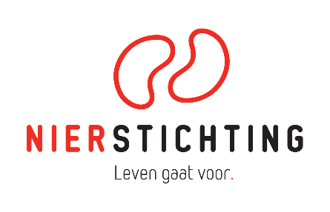
Dutch Kidney Foundation
Research Grant
Review form Final Report
Version 7 May 2019

Secretariaat Zorg & Innovatie / Secretariat Heathcare & Innovation
+31 (0)35 697 8015
research@nierstichting.nl

Instructions for completing and submitting this form
- Your personal details are registered in our grant management system called MIDAS. You can modify your personal details or add information via the system. This review form will be send to the applicant in anonymised form and therefore has no space for your personal details.
- You are asked to fill in your Person ID. This is a unique code, created by MIDAS, that can not be traced back to you personally by the applicant. Please find your Person ID in MIDAS through clicking on the profile picture at the top-right corner of your screen and subsequently choose for Edit my details.
- Please convert the completed form into a searchable PDF file. Upload the PDF file to your digital submission form in MIDAS.

Person ID:

1. Project
Project code
Project title
Acronym (optional)
Applicant name

2. Project Leader
 | poor | fair | good | very good | excellent
Performance
What is your assessment of the project leader’s performance on this project?
Contribution to renal field [only for Kolff Projects]
To what extent does the project leader contribute to the renal field in the Netherlands?
Please review (in text) the project leader along the criteria.

3. Output
 | poor | fair | good | very good | excellent
Results
Has the project improved understanding of the underlying problem?
Deliverables
Has the project delivered what was promised?
Publications
What is your assessment of number and quality of (non-)scientific publications?
Products
Has the project delivered research and/or healthcare products that were promised?
Please review (in text) the output of the project along the criteria.

4. Impact and Valorization
 | poor | fair | good | very good | excellent
Innovation [only for Innovation Projects]
What is the significance of the project for innovation?
Impact: (Future) kidney patients and prevention of kidney disease
Impact: Renal science
Impact: Renal field in the Netherlands
Impact: Society
Cost-benefit
Was the project worth the investment?
Implementation, dissemination and follow-up opportunities
Please review (in text) the impact and valorization of the project results along the criteria.

5. Conclusions
 | poor | fair | good | very good | excellent
Overall
Please summarize (in text) the final results of the project.

6. Recommendation
Approve
Revision
Reject

