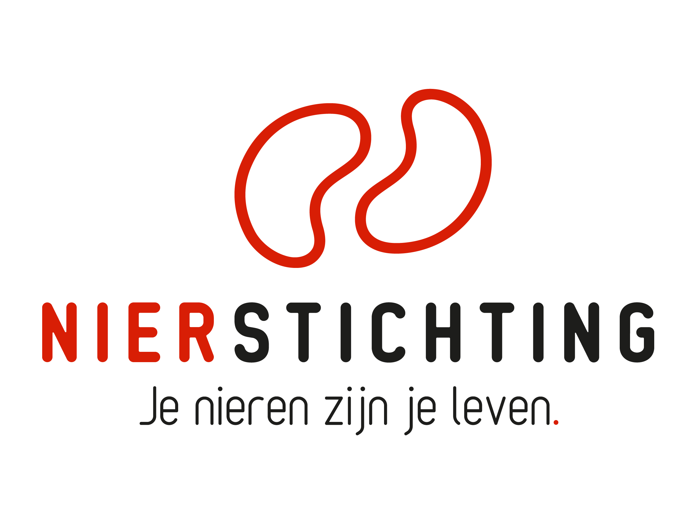
Dutch Kidney Foundation
Final Report form
Kolff Visiting Senior Scientist Grant
20 January 2020

The Dutch Kidney Foundation (DKF) General Grant Requirements (Subsidievoorwaarden Nierstichting Nederland) apply to all awarded DKF subsidies as well as all proposals for DKF subsidies. Applicability of general and other conditions of the applicant, the applicant's institute and of third parties is explicitly excluded.

Nierstichting / Dutch Kidney Foundation
+31 (0)35 697 8015
research@nierstichting.nl

Instructions for completing and submitting this form
- Maximum word counts specified are fixed limits that must not be exceeded. Please fill in the number of words used where asked.
- Forms should be filled in using Arial 10 pt.
- Instructions and/or sections in the form must not be deleted (even if the section is not applicable).
- Please convert the completed final report form, including electronic signatures, in a searchable pdf-file. The maximum file size is 5 MB.

- Applicant, Host Researcher in the Netherlands
Name (M/F)
Address:
Name Institute
Department
Room number
Street name
Postal code, Town/City
Telephone
E-mail
Project leader of DKF Projects (project codes past 6 years if applicable)
Researcher Identification (e.g. ResearcherID, ORCID)

- Visiting Senior Scientist
Name (M/F)
Institute & Department
Address:
Name Institute
Department
Room number
Street name
Postal code, Town/City Country
Telephone
E-mail
Researcher Identification (e.g. ResearcherID, ORCID)

- Visit Period
Start date
End date
Duration in months
DKF budget

- Visit Plan: results and impact (max. 1000 words)
Number of words used:
- Describe concisely the visit plan, add changes in bold script. Provide a short motivation for changes.
- Describe concisely the results of the research activities.
- Give a short description of the impact the visit had on the host, the visitor and both research teams.

- Summary and Conclusions (max. 100 words)
Number of words used:
Summarize the results, draw conclusions.

- Scientific Publications from the project
List the publications (in preparation, submitted, accepted and published) directly resulting from the project. If DOIs or links to web pages are not available, attach PDFs. Please note that PDFs should be uploaded separately from this progress report in MIDAS. Merge multiple PDFs into one file.

Reference | DOI | Link to web page | Open Access via Gold or Green Route*

* The DKF supports and encourages Open Access publishing, preferably via the Gold Route. More information can be found on https://www.openaccess.nl/.

- Other Publications and Output
Provide a complete overview of other publications and output (e.g. articles published or in preparation in public media or publications and output focused on patients or health care professionals). If DOIs or links to web pages are not available, attach PDFs. Please note that PDFs should be uploaded separately from this progress report in MIDAS. Merge multiple PDFs into one file.

- Budget and Additional Funding from other Sources (max. 200 words)
Number of words used:
If applicable, describe and justify changes to the original budget. Use the budget table from the proposal.

- Signatures
 | Name and position | Signature | Date
Applicant

Visitor

Authorisation
(e.g. Head of Department, Head of Institute, Director)

