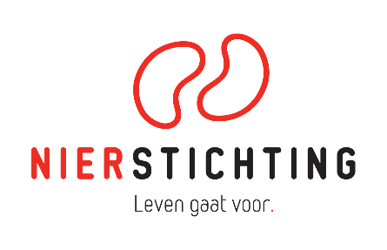
Dutch Kidney Foundation
Kolff Student Fellowship Abroad Grant
Final Report form
Version 7 May 2019

The Dutch Kidney Foundation (DKF) General Grant Requirements (Subsidievoorwaarden Nierstichting Nederland) apply to all awarded DKF subsidies as well as all proposals for DKF subsidies. Applicability of general and other conditions of the applicant, the applicant's institute and of third parties is explicitly excluded.

Secretariaat Zorg & Innovatie / Secretariat Heathcare & Innovation
+31 (0)35 697 8015
research@nierstichting.nl

Instructions for completing and submitting this form
- Maximum word counts specified below are indications for the maximal length of text.
- Please convert the completed final report form into a searchable PDF file. Upload the PDF file to your digital submission form in our grant management system called MIDAS. The maximum file size is 5 MB.

1. Project
Project code
Project title
Acronym (optional)
DKF budget
Reporting date

2. Project Leader in the Netherlands
Name
Institute, Department
Researcher Identification (e.g. ResearcherID, ORCID)

3. Student Fellow
Name
Institute, Department

4. Project Leader Abroad
Name
Institute, Department

5. Duration
Start date
End date
Duration

6. Summary of the Student Fellow Research Project (original and changes; max. 500 words)
If applicable, changes in bold script. Provide a short motivation for changes.

7. Project Results (max. 1000 words)
Give a short description of the results. Add the formal final report of the institute, abstracts and publications as PDF files.

8. Overall Assessment Score
To be filled in by the Project Leader in the Netherlands. Rate using an ‘X’.
How do you assess the scientific quality of the research performed and its documentation in this Final Report?
Poor Fair Average Good Excellent
1.☐ 2.☐ 3.☐ 4.☐ 5.☐

9. Signatures
 | Name and position | Signature | Date
Project leader (NL)

Student fellow
Autorisation (e.g. Head of Department, Head of Institute, Director)

