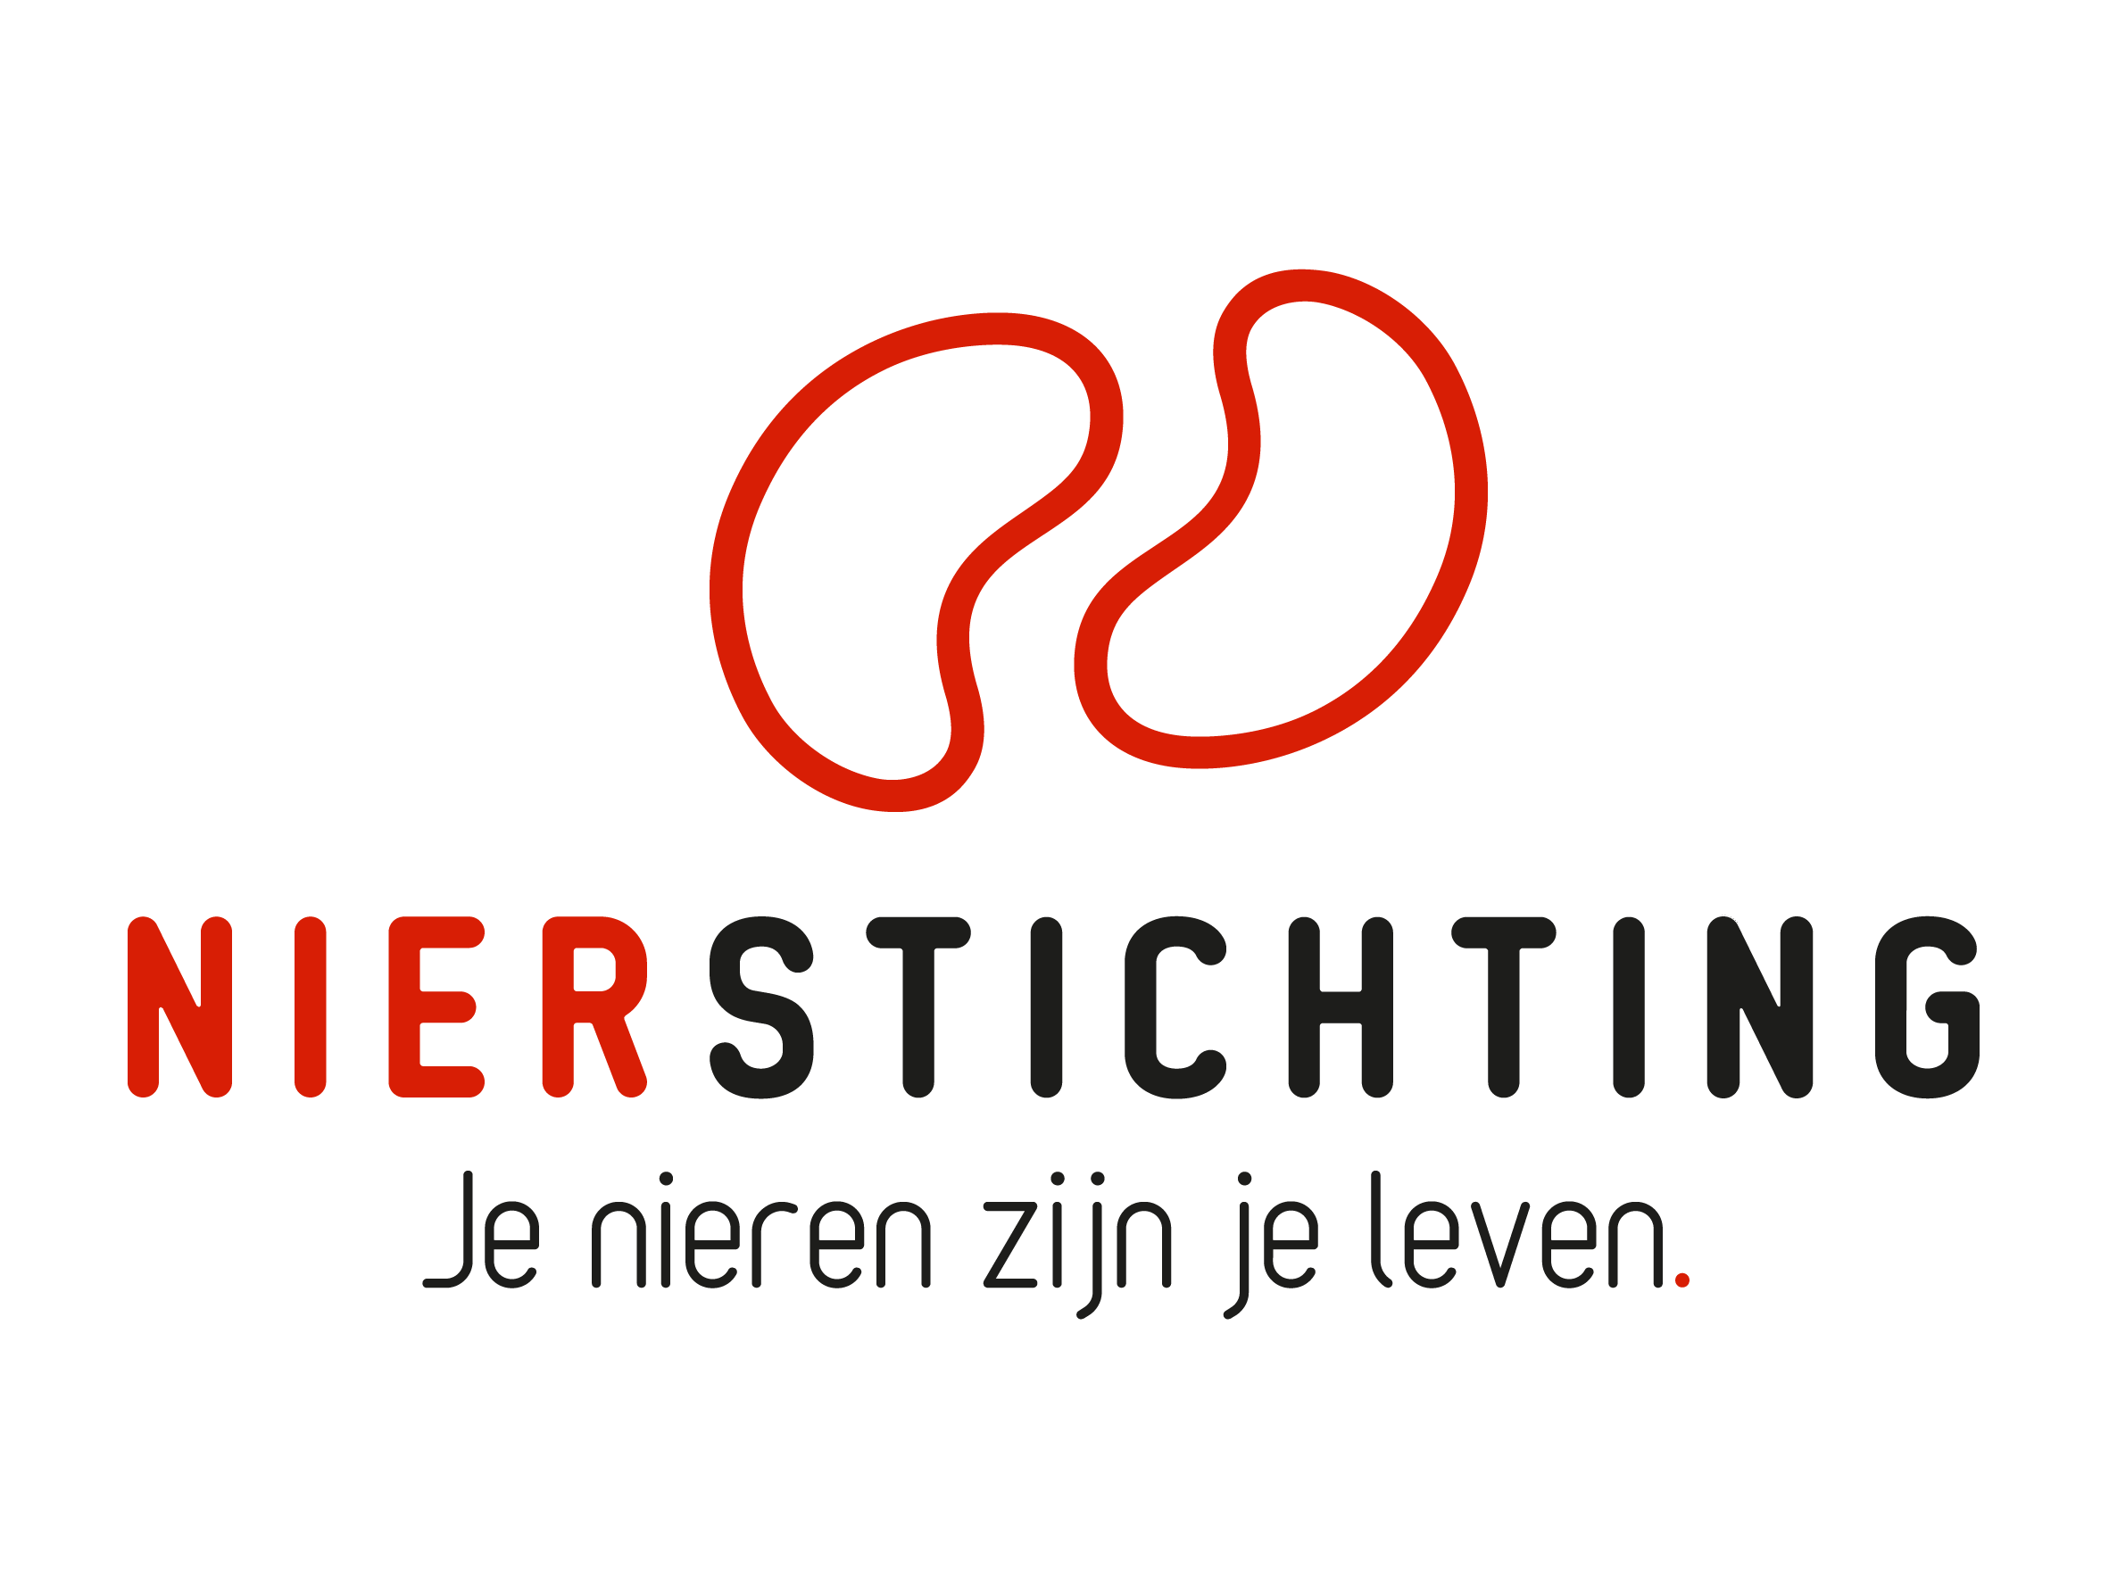
Dutch Kidney Foundation
Final Report form
Consortium Grant
11 May 2021

The Dutch Kidney Foundation (DKF) General Grant Requirements (Subsidievoorwaarden Nierstichting Nederland) apply to all awarded DKF subsidies as well as all proposals for DKF subsidies. Applicability of general and other conditions of the applicant, the applicant's institute and of third parties is explicitly excluded.

Nierstichting / Dutch Kidney Foundation
+31 (0)35 697 8015
research@nierstichting.nl

Instructions for completing and submitting this form
The submitted final report must meet the following conditions for acceptance:
- Maximum word counts specified are fixed limits that must not be exceeded. Please fill in the number of words used where asked.
- Forms should be filled in using Arial 10 pt.
- Please convert the completed application form, including electronic signatures, in a searchable PDF file. Upload the PDF file into your digital submission form in our grant management system called MIDAS. The maximum file size is 5 MB.

Instructions for abridged reporting in case of consortium projects reporting to Health Holland
- Please attach the report that was submitted to Health Holland.
- Please enter all relevant information that was obtained after submitting the report to Health Holland. If an item is already fully described in the Health Holland report you do not need to enter the information again. Please only note down a reference to the relevant section in the Health Holland report.

1. Project
Project code
Project title
Acronym (optional)
DKF budget
Reporting date

2. Principal Investigator
Name
Institute, Department
Researcher Identification (e.g. ResearcherID, ORCID)

3. Duration
Start date
End date
Duration in months
Reported period

Sections
- Research description
- Organisation
- Final results
- Products and development
- Impact and Valorization
- Signatures

I. Research description
(a) Instructions for completing and submitting this form:
If applicable, add changes in the reported period in bold script. Provide motivation for changes. Refer to the progress reports if necessary.
(b) Instructions for abridged reporting in case of consortium projects reporting to Health Holland: Please enter all relevant information that was obtained after submitting the report to Health Holland. If an item is already fully described in the Health Holland report you do not need to enter the information again. Please only note down a reference to the relevant section in the Health Holland report.

1. Changes in Central Hypothesis and Aims (max. 500 words)
Number of words used:
If applicable for the reported period, describe changes in the overall hypothesis, aims & objectives. Provide motivation for changes.

2. Changes in Work Packages
If applicable for the reported period, describe changes to the original workplan (hypothesis, aims & objectives, project plan, time schedules, deliverables, personnel). Provide motivation for changes.

2.1. Work Package 1 (max. 500 words)
Number of words used:

2.2. Work Package 2 (max. 500 words)
Number of words used:

2.3. Work Package X (max. 500 words)
Number of words used:

3. Changes in Time Schedule and Deliverables (max. 300 words)
Number of words used:
If applicable for the reported period, indicate changes in the time schedule and deliverables with respect to the original timeline. Provide motivation for changes.

4. Changes in Inclusion of Patients (max. 300 words)
Number of words used:
If applicable for the reported period, describe and justify changes to the original inclusion plan.

5. Changes in Budget and co-funding (original and changes)
Number of words used:
If applicable for the reported period. If necessary, use the budget table from the proposal.

II. Organisation
(a) Instructions for completing and submitting this form:
If applicable, add changes in the reported period in bold script. Provide motivation for changes. Refer to the progress reports if necessary.
(b) Instructions for abridged reporting in case of consortium projects reporting to Health Holland: Please enter all relevant information that was obtained after submitting the report to Health Holland. If an item is already fully described in the Health Holland report you do not need to enter the information again. Please only note down a reference to the relevant section in the Health Holland report.

1. Personnel Changes
If applicable for the reported period.
Name and title | Function | Institute & Department | Research Team & Work Package(s) | Budget | Dates

2. Changes in the Organisational Structure (max. 500 words)
If applicable for the reported period, describe changes in the consortium structure (participating research teams and their roles, charts of the links between participating teams, work packages and proposed research).

3. Changes within the Research Teams (max. 300 words)
Number of words used:
If applicable for the reported period.

4. Changes in the Management Plan (max. 300 words)
Number of words used:
If applicable for the reported period.

5. Changes in Contact Persons (IPR, financial management)
If applicable for the reported period.
Name new contact (M/F)
Institute
Function
Telephone
Email

III. Final results
(a) Instructions for completing and submitting this form:
Describe the complete results of the Work Packages and of the overall consortium project. Include the results of the consortium's last period. Refer to progress reports if necessary.
(b) Instructions for abridged reporting in case of consortium projects reporting to Health Holland: Please enter all relevant information that was obtained after submitting the report to Health Holland. If an item is already fully described in the Health Holland report you do not need to enter the information again. Please only note down a reference to the relevant section in the Health Holland report.

1. Final Results Work Packages

Work Package 1
Describe the complete results. Order the results along the objectives and aims.

WP1.1. Progress and Results (max. 1000 words)
Number of words used:

WP1.2. Short Summary of Results and Conclusions (max. 200 words)
Number of words used:

Work Package 2
Describe the complete results. Order the results along the objectives and aims.

WP2.1. Progress and Results (max. 1000 words)
Number of words used:

WP2.2. Short Summary of Results and Conclusions (max. 200 words)
Number of words used:

Work Package X
Describe the complete results. Order the results along the objectives and aims.

WPX.1. Progress and Results (max. 1000 words)
Number of words used:

WPX.2. Short Summary of Results and Conclusions (max. 200 words)
Number of words used:

2. Overall Consortium Conclusions (max. 600 words)
Number of words used:
Give the project's conclusions. Address the problem definition, central hypothesis and aims of the consortium. Evaluate the contribution of each work package to the central aims.

3. Publiekssamenvatting resultaten en conclusies (max. 600 words)
Aantal gebruikte woorden:
Geef een beschrijving van de resultaten en conclusies van het project. Beschrijf daarnaast de directe of potentiële impact voor patiëntenzorg. De tekst moet begrijpelijk zijn voor mensen die niet werkzaam zijn in de wetenschap. Vermijdt daarom het gebruik van vaktermen of zorg voor een duidelijke uitleg van het begrip. Deze sectie graag invullen in het Nederlands.

4. Scientific Publications from the Project Specifically
List the publications (in preparation, submitted, accepted and published) directly resulting from the project. Indicate the relevant Work Package. If DOIs or links to web pages are not available, attach PDFs. Please note that PDFs should be uploaded separately from this progress report in MIDAS. Merge multiple PDFs into one file.

WP | Reference | DOI | Link to web page | Open Access via Gold or Green Route*
* The DKF supports and encourages Open Access publishing, preferably via the Gold Route. More information can be found on https://www.openaccess.nl/.

5. Scientific Publications from spin-off and side projects
List the publications (in preparation, submitted, accepted and published) from spin-off and side projects. If DOIs or links to web pages are not available, attach PDFs. Please note that PDFs should be uploaded separately from this progress report in MIDAS. Merge multiple PDFs into one file.

WP | Reference | DOI | Link to web page | Open Access via Gold or Green Route*
* The DKF supports and encourages Open Access publishing, preferably via the Gold Route. More information can be found on https://www.openaccess.nl/.

6. Other Publications and Output
Provide a complete overview of other publications and output (e.g. articles published or in preparation in public media or publications and output focused on patients or health care professionals). If DOIs or links to web pages are not available, attach PDFs. Please note that PDFs should be uploaded separately from this progress report in MIDAS. Merge multiple PDFs into one file.

7. Results and Evaluation of Patient Participation (max. 300 words)
Number of words used:
Describe the involvement of patients (not as subjects) during the study. Assess the strengths and weaknesses of patient participation in the project.

IV. Products AND DEVELOPMENT
Instructions for abridged reporting in case of consortium projects reporting to Health Holland: Please enter all relevant information that was obtained after submitting the report to Health Holland. If an item is already fully described in the Health Holland report you do not need to enter the information again. Please only note down a reference to the relevant section in the Health Holland report.

1. Data Stewardship (max. 250 words)
Describe how data management is organised. Address the application of FAIR Data Principles (see https://www.dtls.nl/fair-data/fair-principles-explained/). If applicable, mention which steps are (planned to be) taken to ensure that data management will be maintained after finishing the project.

2. Research Data
2.1. Data types, quantities and formats (max. 200 words)
Number of words used:

2.2. Data quality and standards (max. 200 words)
Number of words used:

2.3. Privacy protection of participants (max. 200 words)
Number of words used:

2.4. Long-term preservation of data (max. 200 words)
Number of words used:

3. Research and Healthcare Products (max. 250 words)
Number of words used:
Describe the research and healthcare products resulting from the project. Research products: e.g. animal models, assays, biological products, software, research protocols and procedures, laboratory technology. Healthcare products: e.g. medication, devices, software, guidelines, treatment protocols and healthcare procedures.

4. Intellectual Property (max. 250 words)
Number of words used:
Describe the protected knowledge, skills and technology coming forth from this project (e.g. patents, trade secrets, copyrights, trademarks, registered designs).

5. Development (max. 300 words)
Number of words used:
Describe which steps have already been taken to realize implementation of developed knowledge, skills and technology. Moreover, provide details about the next steps and running activities for the implementation. Please refer to the original plans as described in the grant application.

6. Development opportunities and risks (max. 250 words)
Number of words used:
Mention the success factors and obstacles you have experienced in the development steps and which anticipating actions you have taken. Give a description of the risks, opportunities and anticipating actions you may face in the next steps to reach implementation. Consider for example reimbursement, adoption by users, regulatory aspects, uptake in guidelines, manufacturing aspects or future funding.

V. Impact AND Valorization
Instructions for abridged reporting in case of consortium projects reporting to Health Holland: Please enter all relevant information that was obtained after submitting the report to Health Holland. If an item is already fully described in the Health Holland report you do not need to enter the information again. Please only note down a reference to the relevant section in the Health Holland report.

1. Strategy (max. 300 words)
Number of words used:
- How does the project’s outcome support reaching the goals of “Nierziekte de baas”, the joint Dutch renal strategic agenda for innovation and research? (In English "Beating kidney disease".)
- How does the project’s outcome support reaching the goals of the "Nationale Wetenschaps Agenda"?

2. Impact on (future) kidney patients and prevention of kidney disease (max. 500 words)
Number of words used:
- Describe the project’s contribution to the health and quality of life of (future) kidney patients and to the prevention of kidney disease. Show how (future) patients will benefit. Provide expected timings.
- Address communication and dissemination of results to patients.
- Address implementation and application of the products of the project (section IV). Describe special conditions and possible obstacles.
- Include the interaction with patient groups.

3. Impact on renal science (max. 500 words)
Number of words used:
- Describe the project's significance for renal science and technology: e.g. gains in knowledge and advances in research technology; advances in theory, methodology, methods and procedures.
- Address dissemination of results to the scientific community.
- Address the scientific spin-off of the project.

4. Impact on the renal field in the Netherlands (max. 500 words)
Number of words used:
- Describe how the scientific and clinical renal field in the Netherlands benefits from the project.
- Address the benefits for the partners of the project.
- Address the international position of renal research and innovation in the Netherlands.

5. Impact on society (max. 500 words)
Number of words used:
- Describe how the project's results contribute to addressing important societal issues.
- Address the project’s involvement in new opportunities for healthcare innovation and economic activity.

6. Impact on public awareness (max. 200 words)
Number of words used:
- Describe the project’s contribution public awareness of the significance of the kidney.
- Address communication of the consortium to the general public.
- Address the contribution to DKF communication, public relations and fundraising.
- Address the interaction of the consortium with the public.
VI. Signatures

 | Name, position | Signature | Date
Principal Investigator

Authorisation (e.g. Head of Department, Head of Institute, Director)

