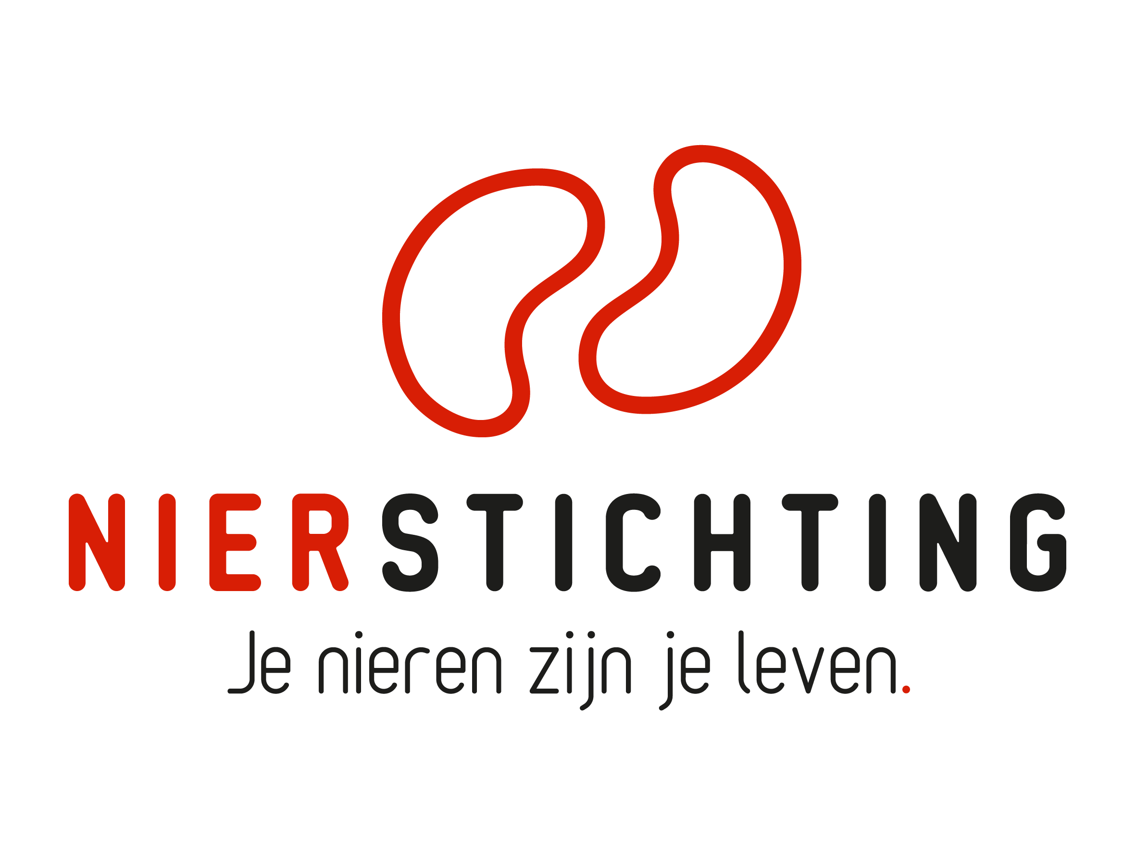
Dutch Kidney Foundation
Final Report form - Large Kolff Grants
Kolff Program
24 December 2019

The Dutch Kidney Foundation (DKF) General Grant Requirements (Subsidievoorwaarden Nierstichting Nederland) apply to all awarded DKF subsidies as well as all proposals for DKF subsidies. Applicability of general and other conditions of the applicant, the applicant's institute and of third parties is explicitly excluded.

Nierstichting / Dutch Kidney Foundation
+31 (0)35 697 8015
research@nierstichting.nl

Instructions for completing and submitting this form
The submitted final report must meet the following conditions for acceptance:
- Maximum word counts specified are fixed limits that must not be exceeded. Please fill in the number of words used where asked.
- Please note that Section III.3 (Publiekssamenvatting resultaten en conclusies) should be completed in Dutch.
- Forms should be filled in using Arial 10 pt.
- Please convert the completed application form, including electronic signatures, in a searchable PDF file. Upload the PDF file into your digital submission form in our grant management system called MIDAS. The maximum file size is 5 MB.

1. Project
Project code
Project title
Acronym (optional)
DKF budget
Reporting date

2. Project Leader
Name
Institute, Department
Researcher Identification (e.g. ResearcherID, ORCID)

3. Duration
Start date
End date
Duration in months
Reported period

Sections
- General information
- Research description
- Final results
- Impact and Valorization
- Signatures

I. general information

1. Participants
Please provide the names of the important funded and non-funded partners in the project.
Name and title | Position | Institute and department | Funding source | Fte | Email address

II. research description
If applicable, add changes in bold script. Provide a short motivation for changes.

1. Scientific Summary (max. 800 words)
Number of words used:

2. Aims and Objectives (max. 350 words)
Number of words used:

3. Personnel (max. 250 words)
Number of words used:

Name and title | Function | Institute and department | Budget | Period of engagement

4. Work Plan Changes (max. 400 words)
Number of words used:
If applicable, describe changes to the original work plan. Provide motivation for changes.

5. Time Schedule and Deliverables (max. 350 words)
Number of words used:
If applicable, indicate clearly the changes with respect to the original timeline.

6. Inclusion of Patients (if applicable, max. 200 words)
Number of words used:
If applicable, describe and justify changes to the original inclusion plan.

7. Budget and Additional Funding from other Sources (max. 200 words)
Number of words used:
If applicable, describe and justify changes to the original budget. Use the budget table from the proposal.

III. Final results

1. Project Results (max. 1000 words)
Number of words used:
Order the results along the given objectives and aims. Describe the complete project; refer to the progress report(s) if necessary.

2. Conclusions (max. 200 words)
Number of words used:
Draw conclusions. Address the original problem definition and hypothesis.

3. Publiekssamenvatting resultaten en conclusies (max. 300 words)
Aantal gebruikte woorden:
Geef een beschrijving van de resultaten en conclusies van het project. Beschrijf daarnaast de directe of potentiële impact voor patiëntenzorg. De tekst moet begrijpelijk zijn voor mensen die niet werkzaam zijn in de wetenschap. Vermijdt daarom het gebruik van vaktermen of zorg voor een duidelijke uitleg van het begrip. Deze sectie graag invullen in het Nederlands.

4. Scientific Publications from the project
List the publications (in preparation, submitted, accepted and published) directly resulting from the project. If DOIs or links to web pages are not available, attach PDFs. Please note that PDFs should be uploaded separately from this progress report in MIDAS. Merge multiple PDFs into one file.

Reference | DOI | Link to web page | Open Access via Gold or Green Route*
* The DKF supports and encourages Open Access publishing, preferably via the Gold Route. More information can be found on https://www.openaccess.nl/.

5. Other Publications and Output
Provide a complete overview of other publications and output (e.g. articles published or in preparation in public media or publications and output focused on patients or health care professionals). If DOIs or links to web pages are not available, attach PDFs. Please note that PDFs should be uploaded separately from this progress report in MIDAS. Merge multiple PDFs into one file.

6. Results and Evaluation of Patient Participation (max. 300 words)
Number of words used:
Describe the involvement of patients (not as subjects) during the study. Provide the most important strengths and weaknesses of patient participation.

IV. Impact AND Valorization

1. Strategy (max. 150 words)
Number of words used:
- How does the project’s outcome support reaching the goals of “Nierziekte de baas”, the joint Dutch renal strategic agenda for innovation and research? (In English "Beating kidney disease".)
- How does the project’s outcome support reaching the goals of the "Nationale Wetenschaps Agenda"?

2. Impact and Valorization (max. 500 words)
Number of words used:
Describe and explain the significance of the project for the following fields.
- Kidney patients, future kidney patients and prevention of kidney disease. Include the communication and dissemination of results to patients.
- Renal science, technology and the renal field (scientific and clinical) in the Netherlands and abroad. Include the dissemination of results to the scientific community.
- Socio-economic aspects and health care innovation. Include the implementation.
- Public awareness for kidney health and communication to the general public.

V. Signatures

 | Name and position | Signature | Date
Project Leader

Authorisation (e.g. Head of Department, Head of Institute, Director)

