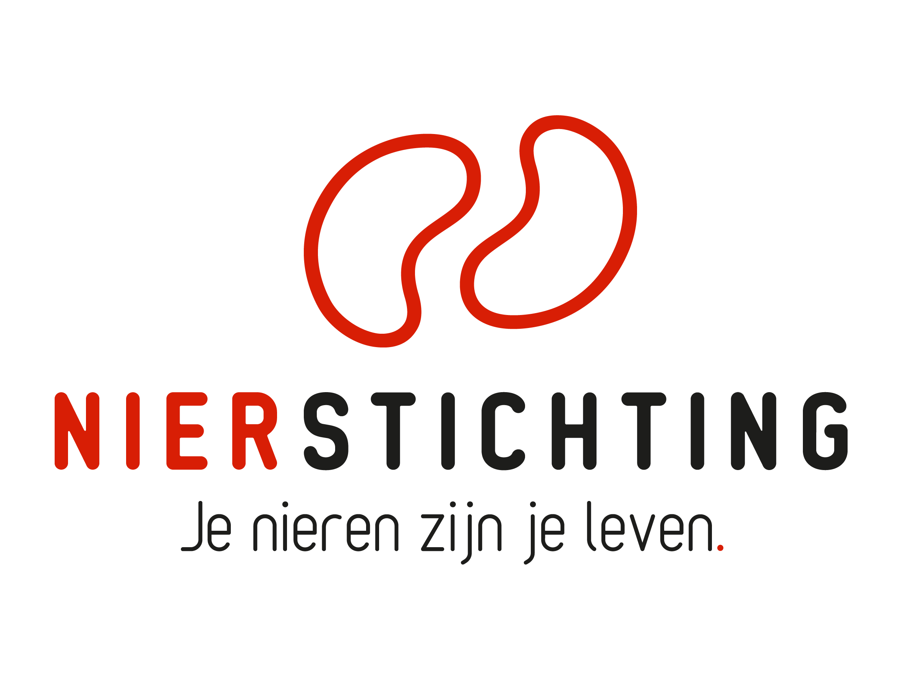
Dutch Kidney Foundation
Review form Midterm Progress Report
Consortium Grant
30 December 2019

Nierstichting / Dutch Kidney Foundation
+31 (0)35 697 8015
research@nierstichting.nl

Instructions for completing and submitting this form
- Your personal details are registered in our grant management system called MIDAS. You can modify your personal details or add information via the system. This review form will be send to the applicant in anonymised form and therefore has no space for your personal details.
- Please convert the completed form into a searchable PDF file. Upload the PDF file to your digital submission form in MIDAS.

1. Project
Project code
Project title
Acronym (optional)
Applicant name

2. Organisation

2.1 Assess the consortium management, performance of the principal investigator and coordination. Evaluate the overall organisation.

2.2 Please give scores (X) based on your own expertise.
 | poor | fair | average | good | excellent
Management
Principal Investigator
Coordination

3. Cohesion

3.1 Assess the consortium cohesion: development of synergy, collaborative progress to the central aim and the translational perspective. Evaluate the overall strength.

3.2 Please give scores (X) based on your own expertise.
 | poor | fair | average | good | excellent
Synergy & additive value
Collaboration
Translational perspective

4. Output so far

4.1 Assess the quality of the forthcoming results of the consortium, progress with respect to the original time path, publications so far. Evaluate the overall midterm progress.

4.2 Please give scores (X) based on your own expertise.
 | poor | fair | average | good | excellent
Results & deliverables
Progress according to plan
Publications

5. Further Progress

5.1 Assess the 3rd/4th/5th year work plans and prospects and obstacles for further progress of the consortium. What are the expectations for further progress?

5.2 Please give scores (X) based on your own expertise.
 | poor | fair | average | good | excellent
Work Plans second part
Obstacles
Prospects

6. Conclusions

6.1 Overall assessment of the consortium progress. What is your recommendation?

6.2 Please give an overall score (X) based on your own expertise.
 | poor | fair | average | good | excellent
Overall

