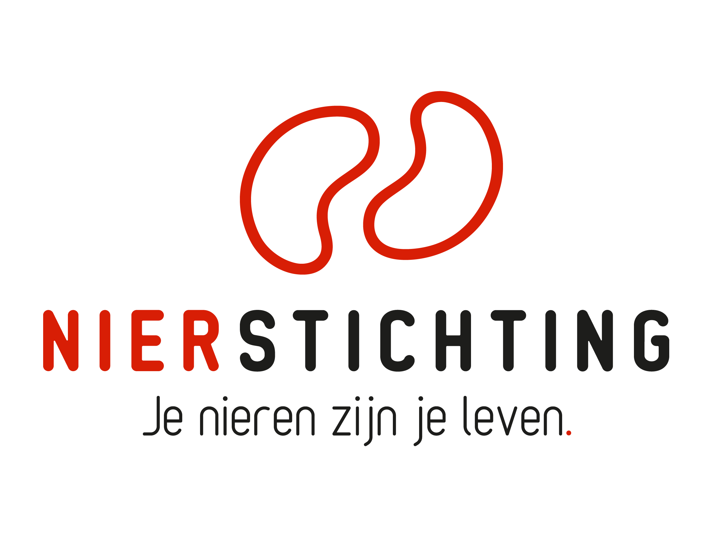
Dutch Kidney Foundation
Review form First Term Progress Report
Consortium Grant
30 December 2019

Nierstichting / Dutch Kidney Foundation
+31 (0)35 697 8015
research@nierstichting.nl

Instructions for completing and submitting this form
- Your personal details are registered in our grant management system called MIDAS. You can modify your personal details or add information via the system. This review form will be send to the applicant in anonymised form and therefore has no space for your personal details.
- Please convert the completed form into a searchable PDF file. Upload the PDF file to your digital submission form in MIDAS.

1. Project
Project code
Project title
Acronym (optional)
Applicant name

2. Organisation

2.1 Assess management, planning and timing of the consortium, development of collaboration and coordination, and (if applicable) changes to the original plan and appointed research positions. Evaluate the overall organisation.

2.2 Please score (X) the organisation based on your own expertise.
poor | fair | average | good | excellent

3. First Year Progress

3.1 Assess the quality and timing of the first results and deliverables of the consortium and (if applicable) changes and delays in the research plan. Evaluate the overall first year progress.

3.2 Please score (X) the first year progress based on your own expertise.
poor | fair | average | good | excellent

4. Further Progress

4.1 Assess prospects and obstacles for further progress of the consortium.

4.2 Please score (X) the further progress based on your own expertise.
poor | fair | average | good | excellent

5. Conclusions

5.1 Overall assessment of the consortium progress.

5.2 Please give an overall score (X) of the consortium progress based on your own expertise.
poor | fair | average | good | excellent

