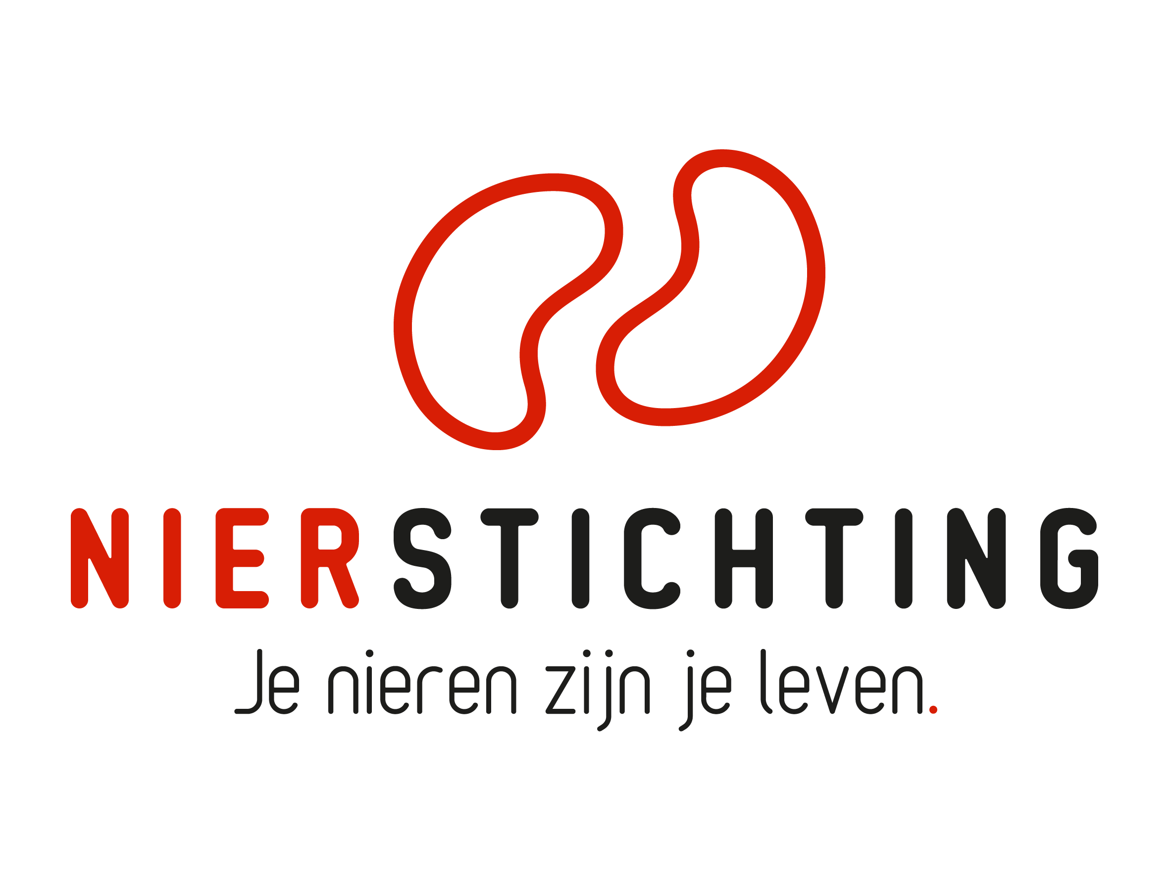
Dutch Kidney Foundation
Midterm Progress Report form
Consortium Grant
11 May 2021

The Dutch Kidney Foundation (DKF) General Grant Requirements (Subsidievoorwaarden Nierstichting Nederland) apply to all awarded DKF subsidies as well as all proposals for DKF subsidies. Applicability of general and other conditions of the applicant, the applicant's institute and of third parties is explicitly excluded.

Nierstichting / Dutch Kidney Foundation
+31 (0)35 697 8015
research@nierstichting.nl

Instructions for completing and submitting this form
The submitted final report must meet the following conditions for acceptance:
- Maximum word counts specified are fixed limits that must not be exceeded. Please fill in the number of words used where asked.
- Forms should be filled in using Arial 10 pt.
- Please convert the completed application form, including electronic signatures, in a searchable PDF file. Upload the PDF file into your digital submission form in our grant management system called MIDAS. The maximum file size is 5 MB.

Instructions for abridged reporting in case of consortium projects reporting to Health Holland
- Please attach the report that was submitted to Health Holland.
- Please enter all relevant information that was obtained after submitting the report to Health Holland. If an item is already fully described in the Health Holland report you do not need to enter the information again. Please only note down a reference to the relevant section in the Health Holland report.

1. Project
Project code
Project title
Acronym (optional)
DKF budget
Reporting date

2. Principal Investigator
Name
Institute, Department
Researcher Identification (e.g. ResearcherID, ORCID)

3. Duration
Start date
Expected end date
Expected duration in months
Reported period

Sections
- Research description
- Organisation
- Progress results
- Signatures
I. Research description
(a) Instructions for completing and submitting this form:
If applicable, add changes in the reported period in bold script. Provide motivation for changes. Refer to the First Term Progress Report if necessary.
(b) Instructions for abridged reporting in case of consortium projects reporting to Health Holland: Please enter all relevant information that was obtained after submitting the report to Health Holland. If an item is already fully described in the Health Holland report you do not need to enter the information again. Please only note down a reference to the relevant section in the Health Holland report.

1. Changes in Central Hypothesis and Aims (original and changes; max. 500 words)
Number of words used:
If applicable for the reported period, describe changes in the overall hypothesis, aims & objectives. Provide motivation for changes.

2. Changes in Work Packages
If applicable for the reported period, describe changes to the original workplan (hypothesis, aims & objectives, project plan, time schedules, deliverables, personnel). Provide motivation for changes. If necessary, give a new Work Package table.

2.1. Work Package 1 (max. 750 words)
Number of words used:

2.2. Work Package 2 (max. 750 words)
Number of words used:

2.3. Work Package X (max. 750 words)
Number of words used:

3. Changes in Time Schedule and Deliverables (max. 300 words)
Number of words used:
If applicable for the reported period, indicate changes in the time schedule and deliverables with respect to the original timeline. Provide motivation for changes.

4. Changes in Inclusion of Patients (max. 300 words)
Number of words used:
If applicable for the reported period, describe and justify changes to the original inclusion plan.

5. Changes in Budget and co-funding (original and changes)
If applicable for the reported period. If necessary, use the budget table from the proposal.
II. Organisation
(a) Instructions for completing and submitting this form:
If applicable, add changes in the reported period in bold script. Provide motivation for changes. Refer to the First Term Progress Report if necessary.
(b) Instructions for abridged reporting in case of consortium projects reporting to Health Holland: Please enter all relevant information that was obtained after submitting the report to Health Holland. If an item is already fully described in the Health Holland report you do not need to enter the information again. Please only note down a reference to the relevant section in the Health Holland report.

1. Personnel Changes
If applicable for the reported period.
Name and title | Function | Institute & Department | Research Team & Work Package(s) | Budget | Dates

2. Changes in the Organisational Structure (max. 300 words)
Number of words used:
If applicable for the reported period, describe changes in the consortium structure (participating research teams and their roles, charts of the links between participating teams, work packages and proposed research).

3. Changes within the Research Teams (max. 300 words)
Number of words used:
If applicable for the reported period.

4. Changes in the Management Plan (max. 300 words)
Number of words used:
If applicable for the reported period.

5. Changes in Contact Persons (IPR, financial management)
If applicable for the reported period.
Name new contact (M/F)
Institute
Function
Telephone
Email

III. Progress results
(a) Instructions for completing and submitting this form:
Describe the progress results of the reported period. Refer to the First Term Progress Report if necessary.
(b) Instructions for abridged reporting in case of consortium projects reporting to Health Holland: Please enter all relevant information that was obtained after submitting the report to Health Holland. If an item is already fully described in the Health Holland report you do not need to enter the information again. Please only note down a reference to the relevant section in the Health Holland report.

1. Progress Results Work Packages

Work Package 1
Order the results along the objectives and aims.

WP1.1. Progress and Results (max. 1000 words)
Number of words used:

WP1.2. Short Summary of Results and Intermediate Conclusions (max. 200 words)
Number of words used:

Work Package 2
Order the results along the objectives and aims.

WP2.1. Progress and Results (max. 1000 words)
Number of words used:

WP2.2. Short Summary of Results and Intermediate Conclusions (max. 200 words)
Number of words used:

Work Package X
Order the results along the objectives and aims.

WPX.1. Progress and Results (max. 1000 words)
Number of words used:

WPX.2. Short Summary of Results and Intermediate Conclusions (max. 200 words)
Number of words used:

2. Scientific Publications from the Project Specifically
If applicable, list the publications (in preparation, submitted, accepted and published) directly resulting from the project. Indicate the relevant Work Package. If DOIs or links to web pages are not available, attach PDFs. Please note that PDFs should be uploaded separately from this progress report in MIDAS. Merge multiple PDFs into one file.

WP | Reference | DOI | Link to web page | Open Access via Gold or Green Route*
* The DKF supports and encourages Open Access publishing, preferably via the Gold Route. More information can be found on https://www.openaccess.nl/.

3. Other Publications and Output
Provide a complete overview of other publications and output (e.g. articles published or in preparation in public media or publications and output focused on patients or health care professionals). If DOIs or links to web pages are not available, attach PDFs. Please note that PDFs should be uploaded separately from this progress report in MIDAS. Merge multiple PDFs into one file.

4. Overall Consortium Progress (max. 1000 words)
Number of words used:
Give an overview of the project's progress in the second term and connect with the Consortium Gantt chart. If applicable, indicate the consequences of changes. Evaluate the contribution of each work package to the central aims.

5. Possible Obstacles for Further Progress (max. 400 words)
Number of words used:
Specify possible obstacles for further progress of the Consortium and ways to address these. If applicable, pay special attention to the inclusion of patients.

6. Opportunities for Communication and PR (max. 200 words)
Number of words used:
Describe the possibilities for the DKF to apply results of the project in communication and PR (e.g. public media and presentations).

7. Research Products & Intellectual Property (max. 200 words)
Number of words used:
If applicable.

8. Work Package: Detailed Plans Second Half of the Project

8.1. Work Package 1 (max. 1000 words)
Number of words used:

8.2. Work Package 2 (max. 1000 words)
Number of words used:

8.3. Work Package X (max. 1000 words)
Number of words used:

IV. Signatures

 | Name, position | Signature | Date
Principal Investigator

Authorisation (e.g. Head of Department, Head of Institute, Director)

