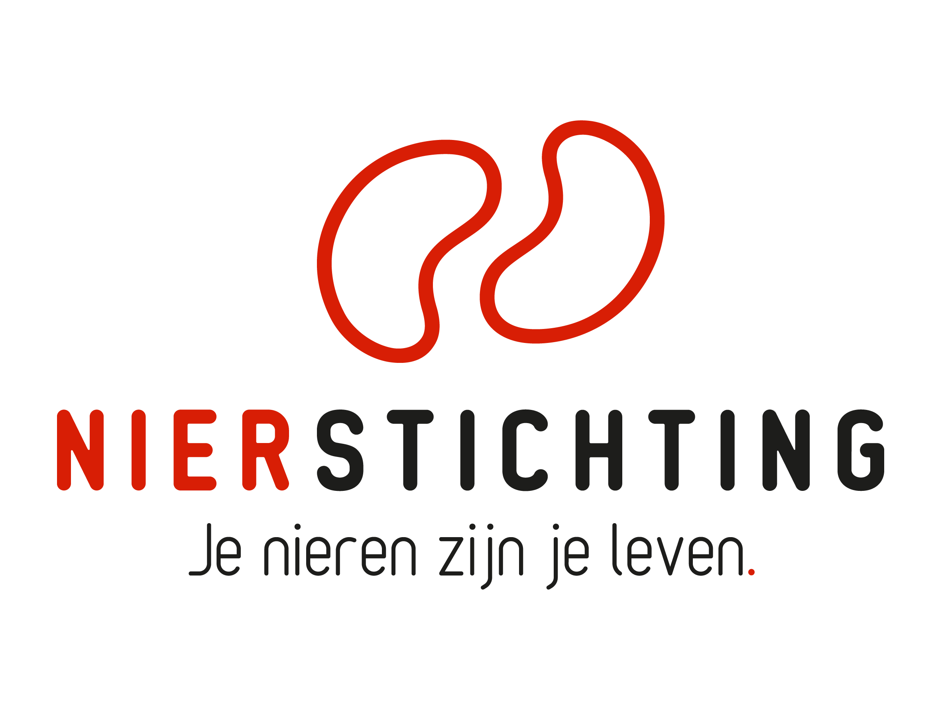
Dutch Kidney Foundation
First Term Progress Report form
Consortium Grant
11 May 2021

The Dutch Kidney Foundation (DKF) General Grant Requirements (Subsidievoorwaarden Nierstichting Nederland) apply to all awarded DKF subsidies as well as all proposals for DKF subsidies. Applicability of general and other conditions of the applicant, the applicant's institute and of third parties is explicitly excluded.

Nierstichting / Dutch Kidney Foundation
+31 (0)35 697 8015
research@nierstichting.nl

Instructions for completing and submitting this form
The submitted final report must meet the following conditions for acceptance:
- Maximum word counts specified are fixed limits that must not be exceeded. Please fill in the number of words used where asked.
- Forms should be filled in using Arial 10 pt.
- Please convert the completed application form, including electronic signatures, in a searchable PDF file. Upload the PDF file into your digital submission form in our grant management system called MIDAS. The maximum file size is 5 MB.

Instructions for abridged reporting in case of consortium projects reporting to Health Holland
- Please attach the report that was submitted to Health Holland.
- Please enter all relevant information that was obtained after submitting the report to Health Holland. If an item is already fully described in the Health Holland report you do not need to enter the information again. Please only note down a reference to the relevant section in the Health Holland report.

1. Project
Project code
Project title
Acronym (optional)
DKF budget
Reporting date

2. Principal Investigator
Name
Institute, Department
Researcher Identification (e.g. ResearcherID, ORCID)

3. Duration
Start date
Expected end date
Expected duration in months
Reported period

Sections
- Organisation
- Progress results
- Signatures
I. Organisation
Instructions for abridged reporting in case of consortium projects reporting to Health Holland: Please enter all relevant information that was obtained after submitting the report to Health Holland. If an item is already fully described in the Health Holland report you do not need to enter the information again. Please only note down a reference to the relevant section in the Health Holland report.

1. Appointed Personnel
Specify appointed personnel.

Researcher / Non-Scientific Personnel 1
Name (M/F)
Function
Hiring Institute, Department
Research Team & Work Package(s)
Start Date, Fte, Duration
Email

Researcher / Non-Scientific Personnel 2
Name (M/F)
Function
Hiring Institute, Department
Research Team & Work Package(s)
Start Date, Fte, Duration
Email

Researcher / Non-Scientific Personnel X
Name (M/F)
Function
Hiring Institute, Department
Research Team & Work Package(s)
Start Date, Fte, Duration
Email

2. Organisational Changes (max. 400 words)
Number of words used:
If applicable, describe changes in the consortium structure.

2.1. Research Teams & Investigators

2.2. Overall Organisation & Management Plan

3. Set-up of the Organisation (max. 500 words)
Number of words used:
Describe and qualify the collaboration and coordination within the consortium.

II. PROGRESS Results
Instructions for abridged reporting in case of consortium projects reporting to Health Holland: Please enter all relevant information that was obtained after submitting the report to Health Holland. If an item is already fully described in the Health Holland report you do not need to enter the information again. Please only note down a reference to the relevant section in the Health Holland report.

1. First Results
Describe work package first results and deliverables.

1.1. Work package 1 (max. 500 words)
Number of words used:

1.2. Work package 2 (max. 500 words)
Number of words used:

1.3. Work package X (max. 500 words)
Number of words used:

2. Short Summary of First Results (max. 400 words)
Number of words used:
Summarize the results.

3. Scientific Publications from the Project Specifically
If applicable, list the publications (in preparation, submitted, accepted and published) directly resulting from the project. Indicate the relevant Work Package. If DOIs or links to web pages are not available, attach PDFs. Please note that PDFs should be uploaded separately from this progress report in MIDAS. Merge multiple PDFs into one file.

WP | Reference | DOI | Link to web page | Open Access via Gold or Green Route*
* The DKF supports and encourages Open Access publishing, preferably via the Gold Route. More information can be found on https://www.openaccess.nl/.

4. Other Publications and Output
Provide a complete overview of other publications and output (e.g. articles published or in preparation in public media or publications and output focused on patients or health care professionals). If DOIs or links to web pages are not available, attach PDFs. Please note that PDFs should be uploaded separately from this progress report in MIDAS. Merge multiple PDFs into one file.

5. Changes in Work Packages
If applicable, describe changes to the original workplan (hypothesis, aims & objectives, project plan, time schedules, deliverables, personnel). Provide motivation for changes. If necessary, give a new Work Package table.

5.1. Work Package 1

5.2. Work Package 2

5.3. Work Package X

5.4. Work Package Table
 | Research Team(s) | Personnel
Work Package 1
Work Package 2
Work Package X

5.5. Overall Consortium

6. Overall Consortium Progress (max. 500 words)
Number of words used:
Give an overview of the consortium's progress and connect with the Consortium Gantt chart. If applicable, clearly indicate changes, delays and their consequences. Provide motivation for changes. Specify possible obstacles for further progress of the consortium and ways to address these.

III. Signatures

 | Name, position | Signature | Date
Principal Investigator

Authorisation (e.g. Head of Department, Head of Institute, Director)

