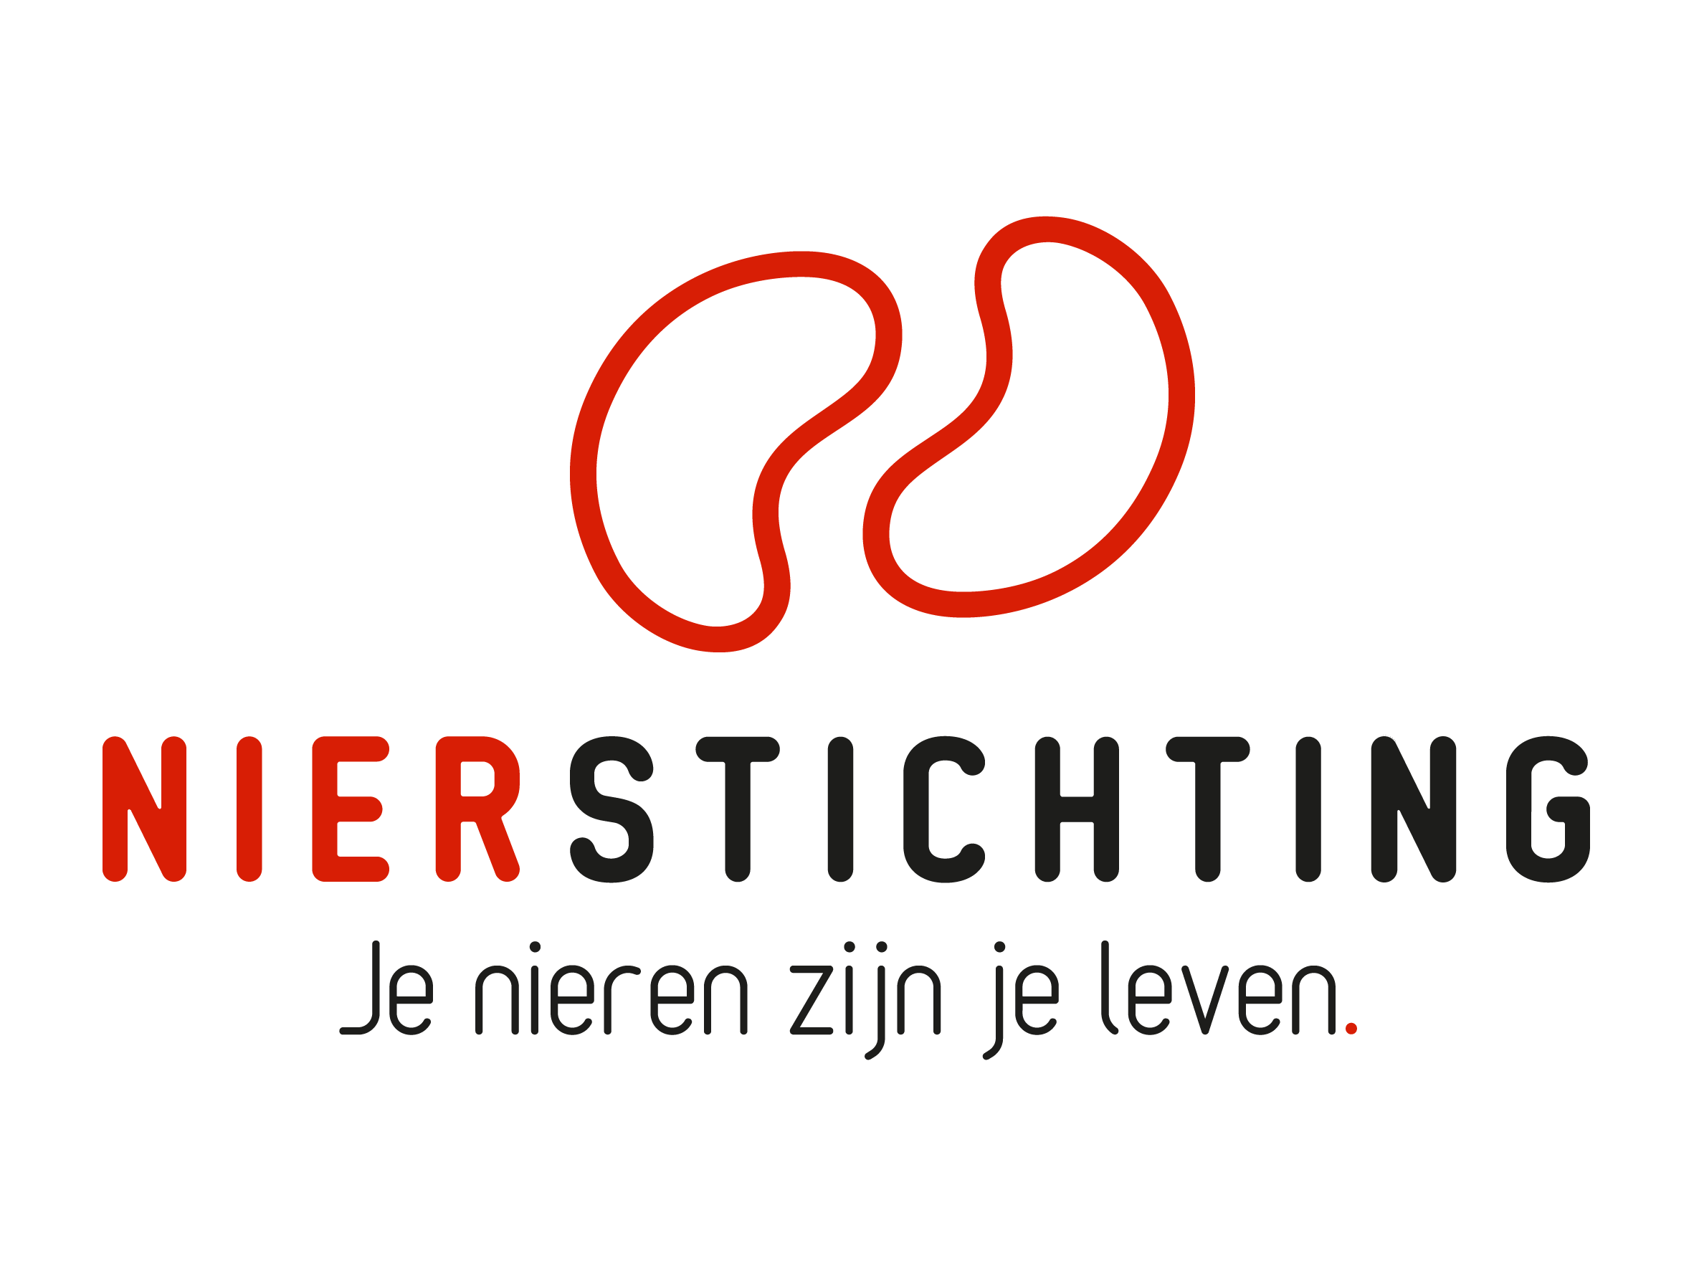
Dutch Kidney Foundation
Progress Report form - Large Kolff Grants
Kolff Program
24 December 2019

The Dutch Kidney Foundation (DKF) General Grant Requirements (Subsidievoorwaarden Nierstichting Nederland) apply to all awarded DKF subsidies as well as all proposals for DKF subsidies. Applicability of general and other conditions of the applicant, the applicant's institute and of third parties is explicitly excluded.

Nierstichting / Dutch Kidney Foundation
+31 (0)35 697 8015
research@nierstichting.nl

Instructions for completing and submitting this form
The submitted final report must meet the following conditions for acceptance:
- Maximum word counts specified are fixed limits that must not be exceeded. Please fill in the number of words used where asked.
- Forms should be filled in using Arial 10 pt.
- Please convert the completed application form, including electronic signatures, in a searchable PDF file. Upload the PDF file into your digital submission form in our grant management system called MIDAS. The maximum file size is 5 MB.

1. Project
Project code
Project title
Acronym (optional)
DKF budget
Reporting date

2. Project Leader
Name
Institute, Department
Researcher Identification (e.g. ResearcherID, ORCID)

3. Duration
Start date
Expected end date
Expected duration in months
Reported period

Sections
- General information
- Research description
- Progress results
- Signatures

I. general information

1. Participants
Please provide the names of the important funded and non-funded partners in the project.
Name and title | Position | Institute and department | Funding source | Fte | Email address

II. RESEARCH Description
If applicable, add changes in bold script. Provide a short motivation for changes.

1. Scientific Summary (max. 800 words)
Number of words used:

2. Aims and Objectives (max. 350 words)
Number of words used:

3. Personnel (max. 250 words)
Number of words used:

4. Work Plan Changes: Reported Period (max. 400 words)
Number of words used:
If applicable, describe changes to the original work plan. Provide motivation for changes.

5. Detailed Work Plan Next Period (max. 1500 words)
Number of words used:

6. Time Schedule and Deliverables (max. 350 words)
Number of words used:
If applicable, indicate clearly the changes with respect to the original timeline.

7. Inclusion of Patients (if applicable, max. 200 words)
Number of words used:
If applicable, describe and justify changes to the original inclusion plan.

8. Budget and Additional Funding from other Sources (max. 200 words)
Number of words used:
If applicable, describe and justify changes to the original budget. Use the budget table from the proposal.

III. Progress results

1. Project Progress and Results (max. 1000 words)
Number of words used:
Order the results along the given objectives and aims.

2. Short Summary of Results and Intermediate Conclusions (max. 200 words)
Number of words used:
Summarize the results, draw intermediate conclusions.

3. Scientific Publications from the project
List the publications (in preparation, submitted, accepted and published) directly resulting from the project. If DOIs or links to web pages are not available, attach PDFs. Please note that PDFs should be uploaded separately from this progress report in MIDAS. Merge multiple PDFs into one file.

Reference | DOI | Link to web page | Open Access via Gold or Green Route*
* The DKF supports and encourages Open Access publishing, preferably via the Gold Route. More information can be found on https://www.openaccess.nl/.

4. Other Publications and Output
Provide a complete overview of other publications and output (e.g. articles published or in preparation in public media or publications and output focused on patients or health care professionals). If DOIs or links to web pages are not available, attach PDFs. Please note that PDFs should be uploaded separately from this progress report in MIDAS. Merge multiple PDFs into one file.

5. Possible Obstacles for Further Progress (max. 300 words)
Number of words used:
Specify possible obstacles for further progress of the project and ways to address these. If applicable, pay special attention to the inclusion of patients.

6. Opportunities for Communication and PR (max. 200 words)
Number of words used:
Describe the possibilities for the DKF to apply results of the project in communication and PR (e.g. public media and presentations).

IV. Signatures

 | Name and position | Signature | Date
Project Leader

Authorisation (e.g. Head of Department, Head of Institute, Director)

