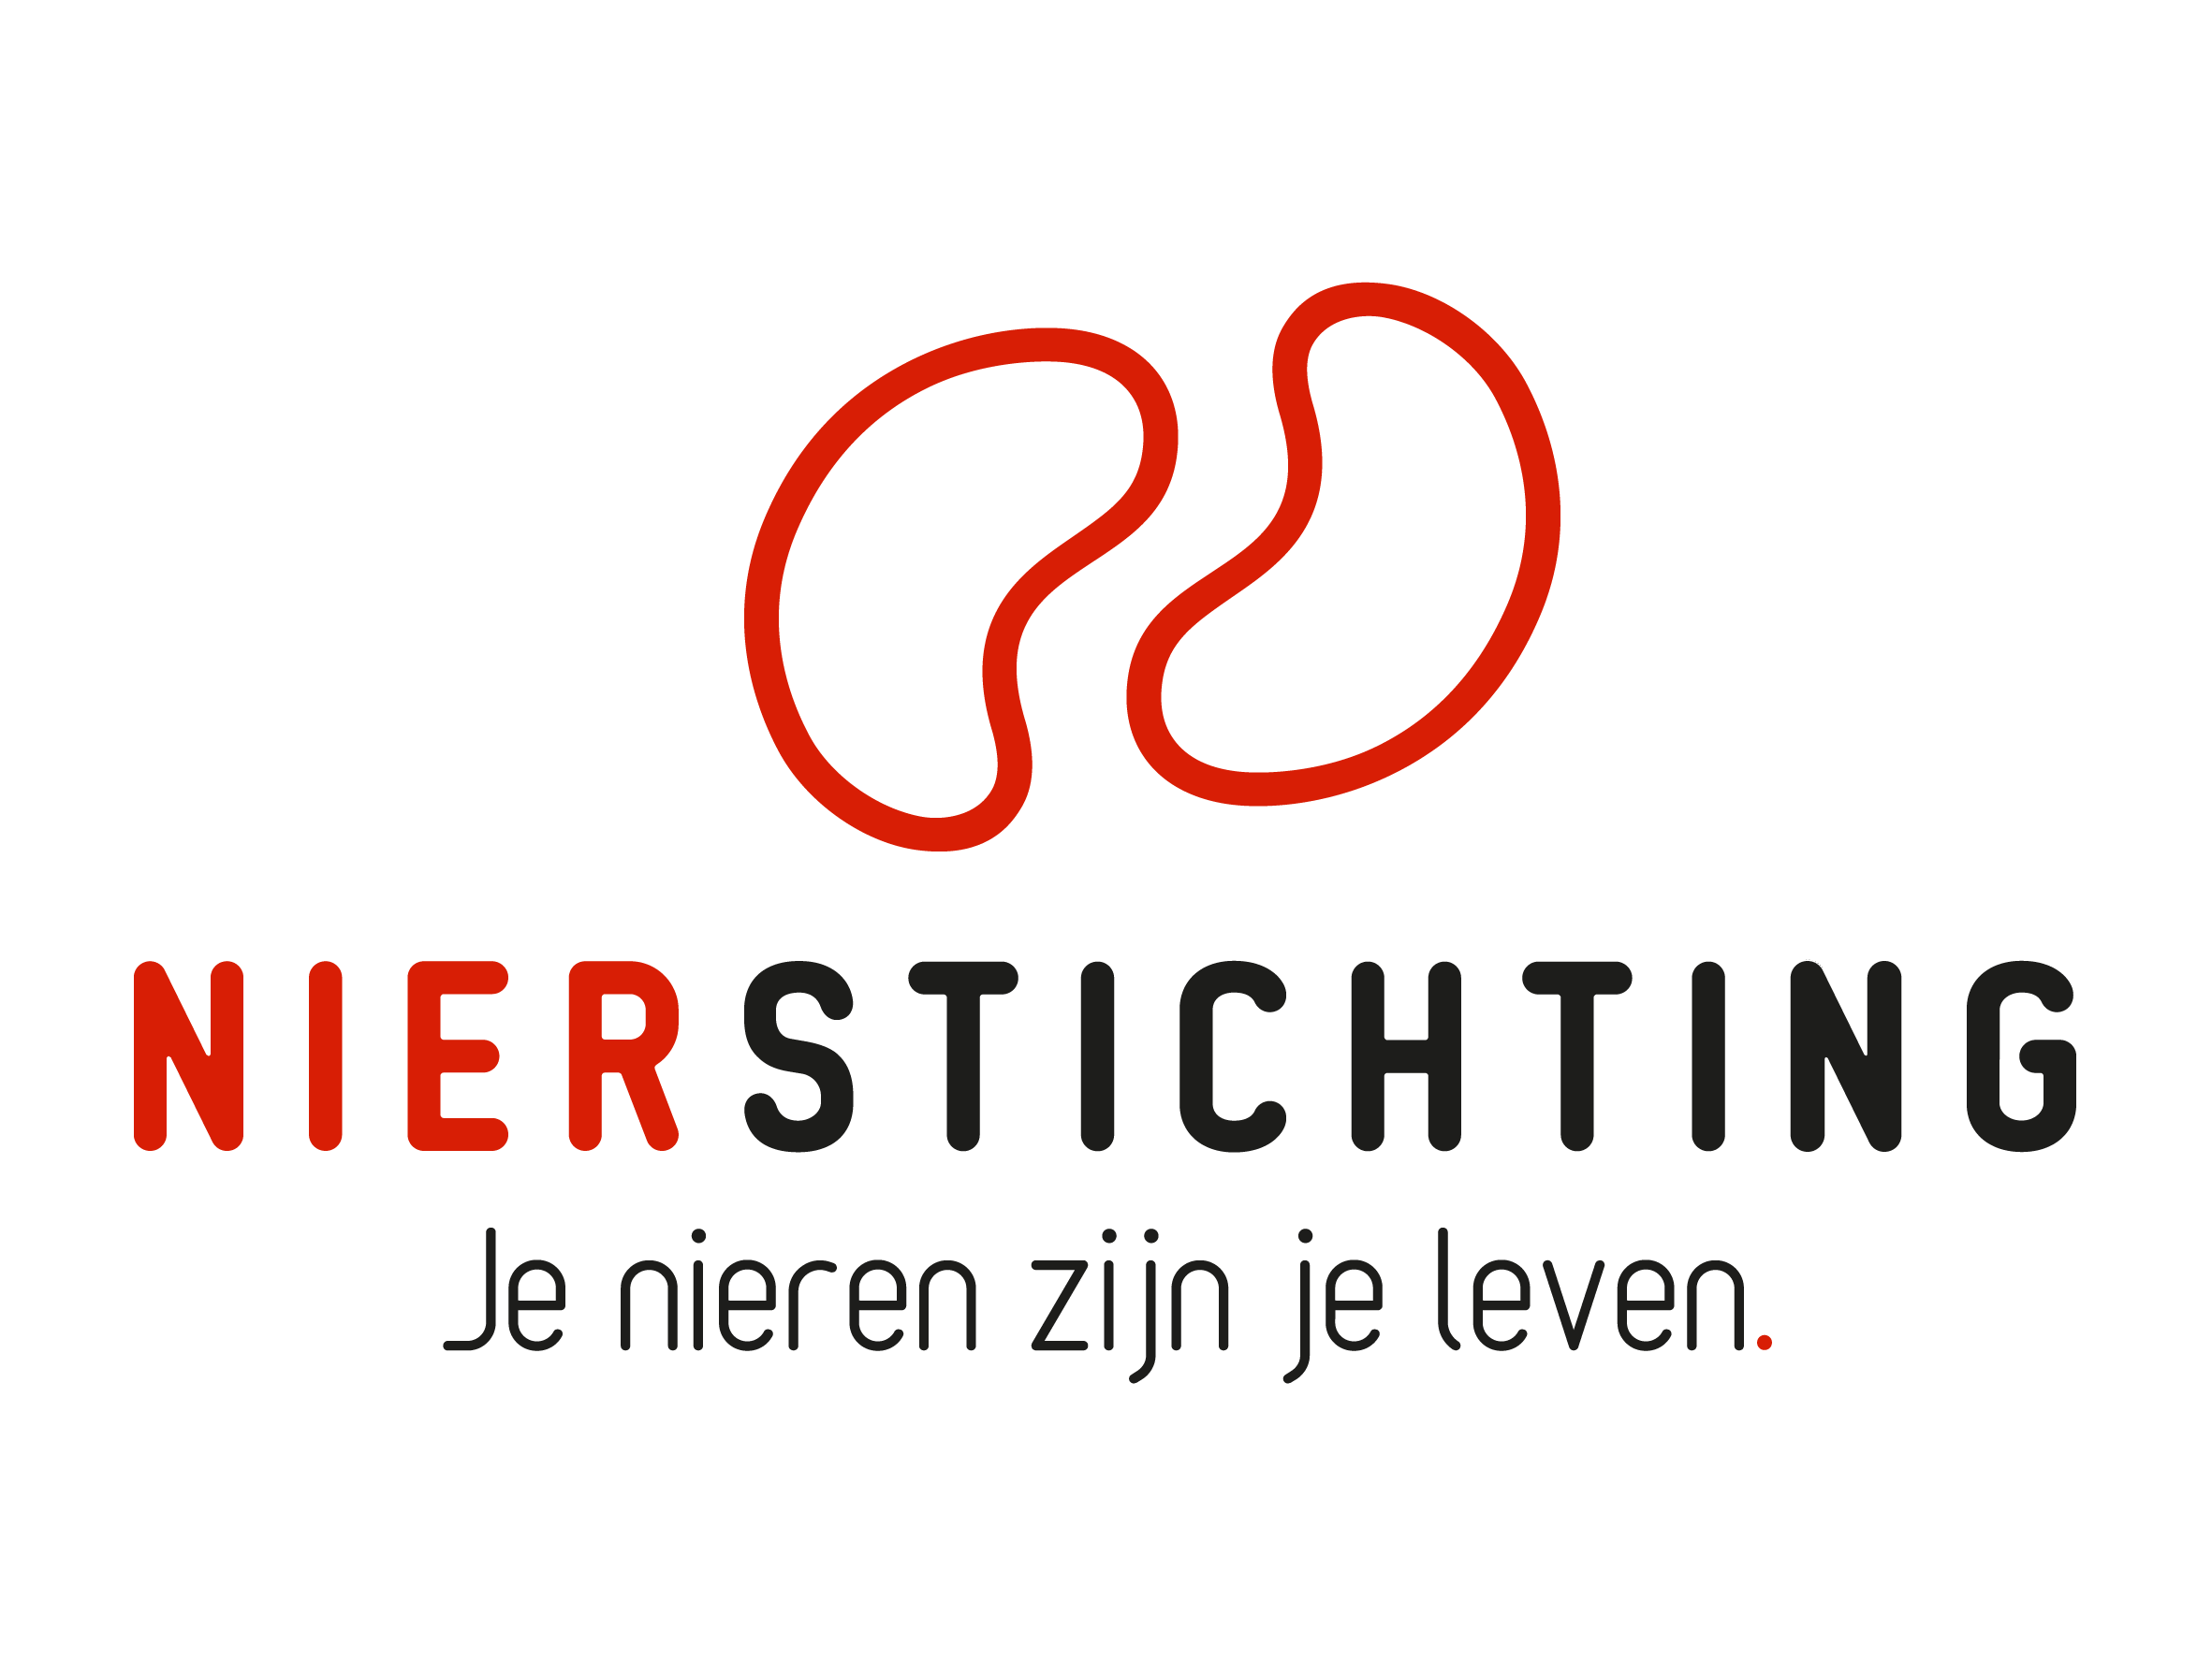
Dutch Kidney Foundation
Rebuttal form Kolff+ Program
7 October 2021

The Dutch Kidney Foundation (DKF) General Grant Requirements (Subsidievoorwaarden Nierstichting Nederland) apply to all awarded DKF subsidies as well as all proposals for DKF subsidies. Applicability of general and other conditions of the applicant, the applicant's institute and of third parties is explicitly excluded.

Disclaimer
The execution of a DKF Call for proposals, selection of pre-proposals for full application and positive DKF grant award decisions are conditional on DKF revenues and budgetary means. The DKF explicitly reserves the right to cancel an initiated Call for proposals, to suspend a running procedure or to lower a grant amount in relation to earlier statements.

Nierstichting / Dutch Kidney Foundation
+31 (0)35 697 8015
research@nierstichting.nl

Instructions for completing and submitting this form
The submitted rebuttal must meet the following conditions for acceptance in this call:
- Do not exceed maximum word counts specified, these are fixed limits. Copied text from reviews must be included in the word counts. Please fill in the number of words used where asked.
- Images (figures, tables, etc.) can be added in the text of section 3 (Rebuttal) and must each have a readable format and size. All images taken together must not exceed 2 pages and legends will count towards the maximum word count of section 3 (Rebuttal). No images are allowed in other sections.
- Please use Arial 10 pt while filling in this form.
- Do not delete instructions and/or sections in the form (even if the section is not applicable).
- Please convert the completed application form, including electronic signatures, into a searchable PDF file. Upload the PDF file into your digital submission form in our grant management system called MIDAS. The maximum file size is 5 MB. Attachments and hyperlinks in this form are not accepted.

1. Project title, type of Kolff+ Grant and Proposed DKF budget

Project Title
Grant type (only one possible answer, place an X in front of the right grant type) | ☐ Creativity Grant  ☐ Junior Talent Grant  ☐ Senior Talent Grant  ☐ Success Accelerator Grant
Proposed DKF budget

2. Applicant
Name (M/F)
Institute, Department
Room number
Postbox
Postal code, Town/City
Phone
Email
Researcher Identification (e.g. ResearcherID, ORCID)

3. Rebuttal (Creativity grant max 1000 words; Talent and Succes grants max. 2000 words)
Number of words used:
Concerning the scientific content and opinions as stated in the reviews of the international reviewers and the comments and questions from the patient perspective by patient reviewers. Please respond to the comments of the international reviewers in English and to those of the patient reviewers in Dutch.

4. Conclusions (max. 400 words)
Number of words used:
Address the overall assessments of the international reviewers and patient reviewers (in English).

5. Other Comments (max. 200 words)
Number of words used:
If applicable, comment on non-scientific aspects of the review process and the reviews (e.g. concerning possible biases, procedural problems or possible conflicts of interest).

6. Signature
 | Name and position | Signature | Date
Applicant

Authorisation
(e.g. Head of Department, Head of Institute, Director)

