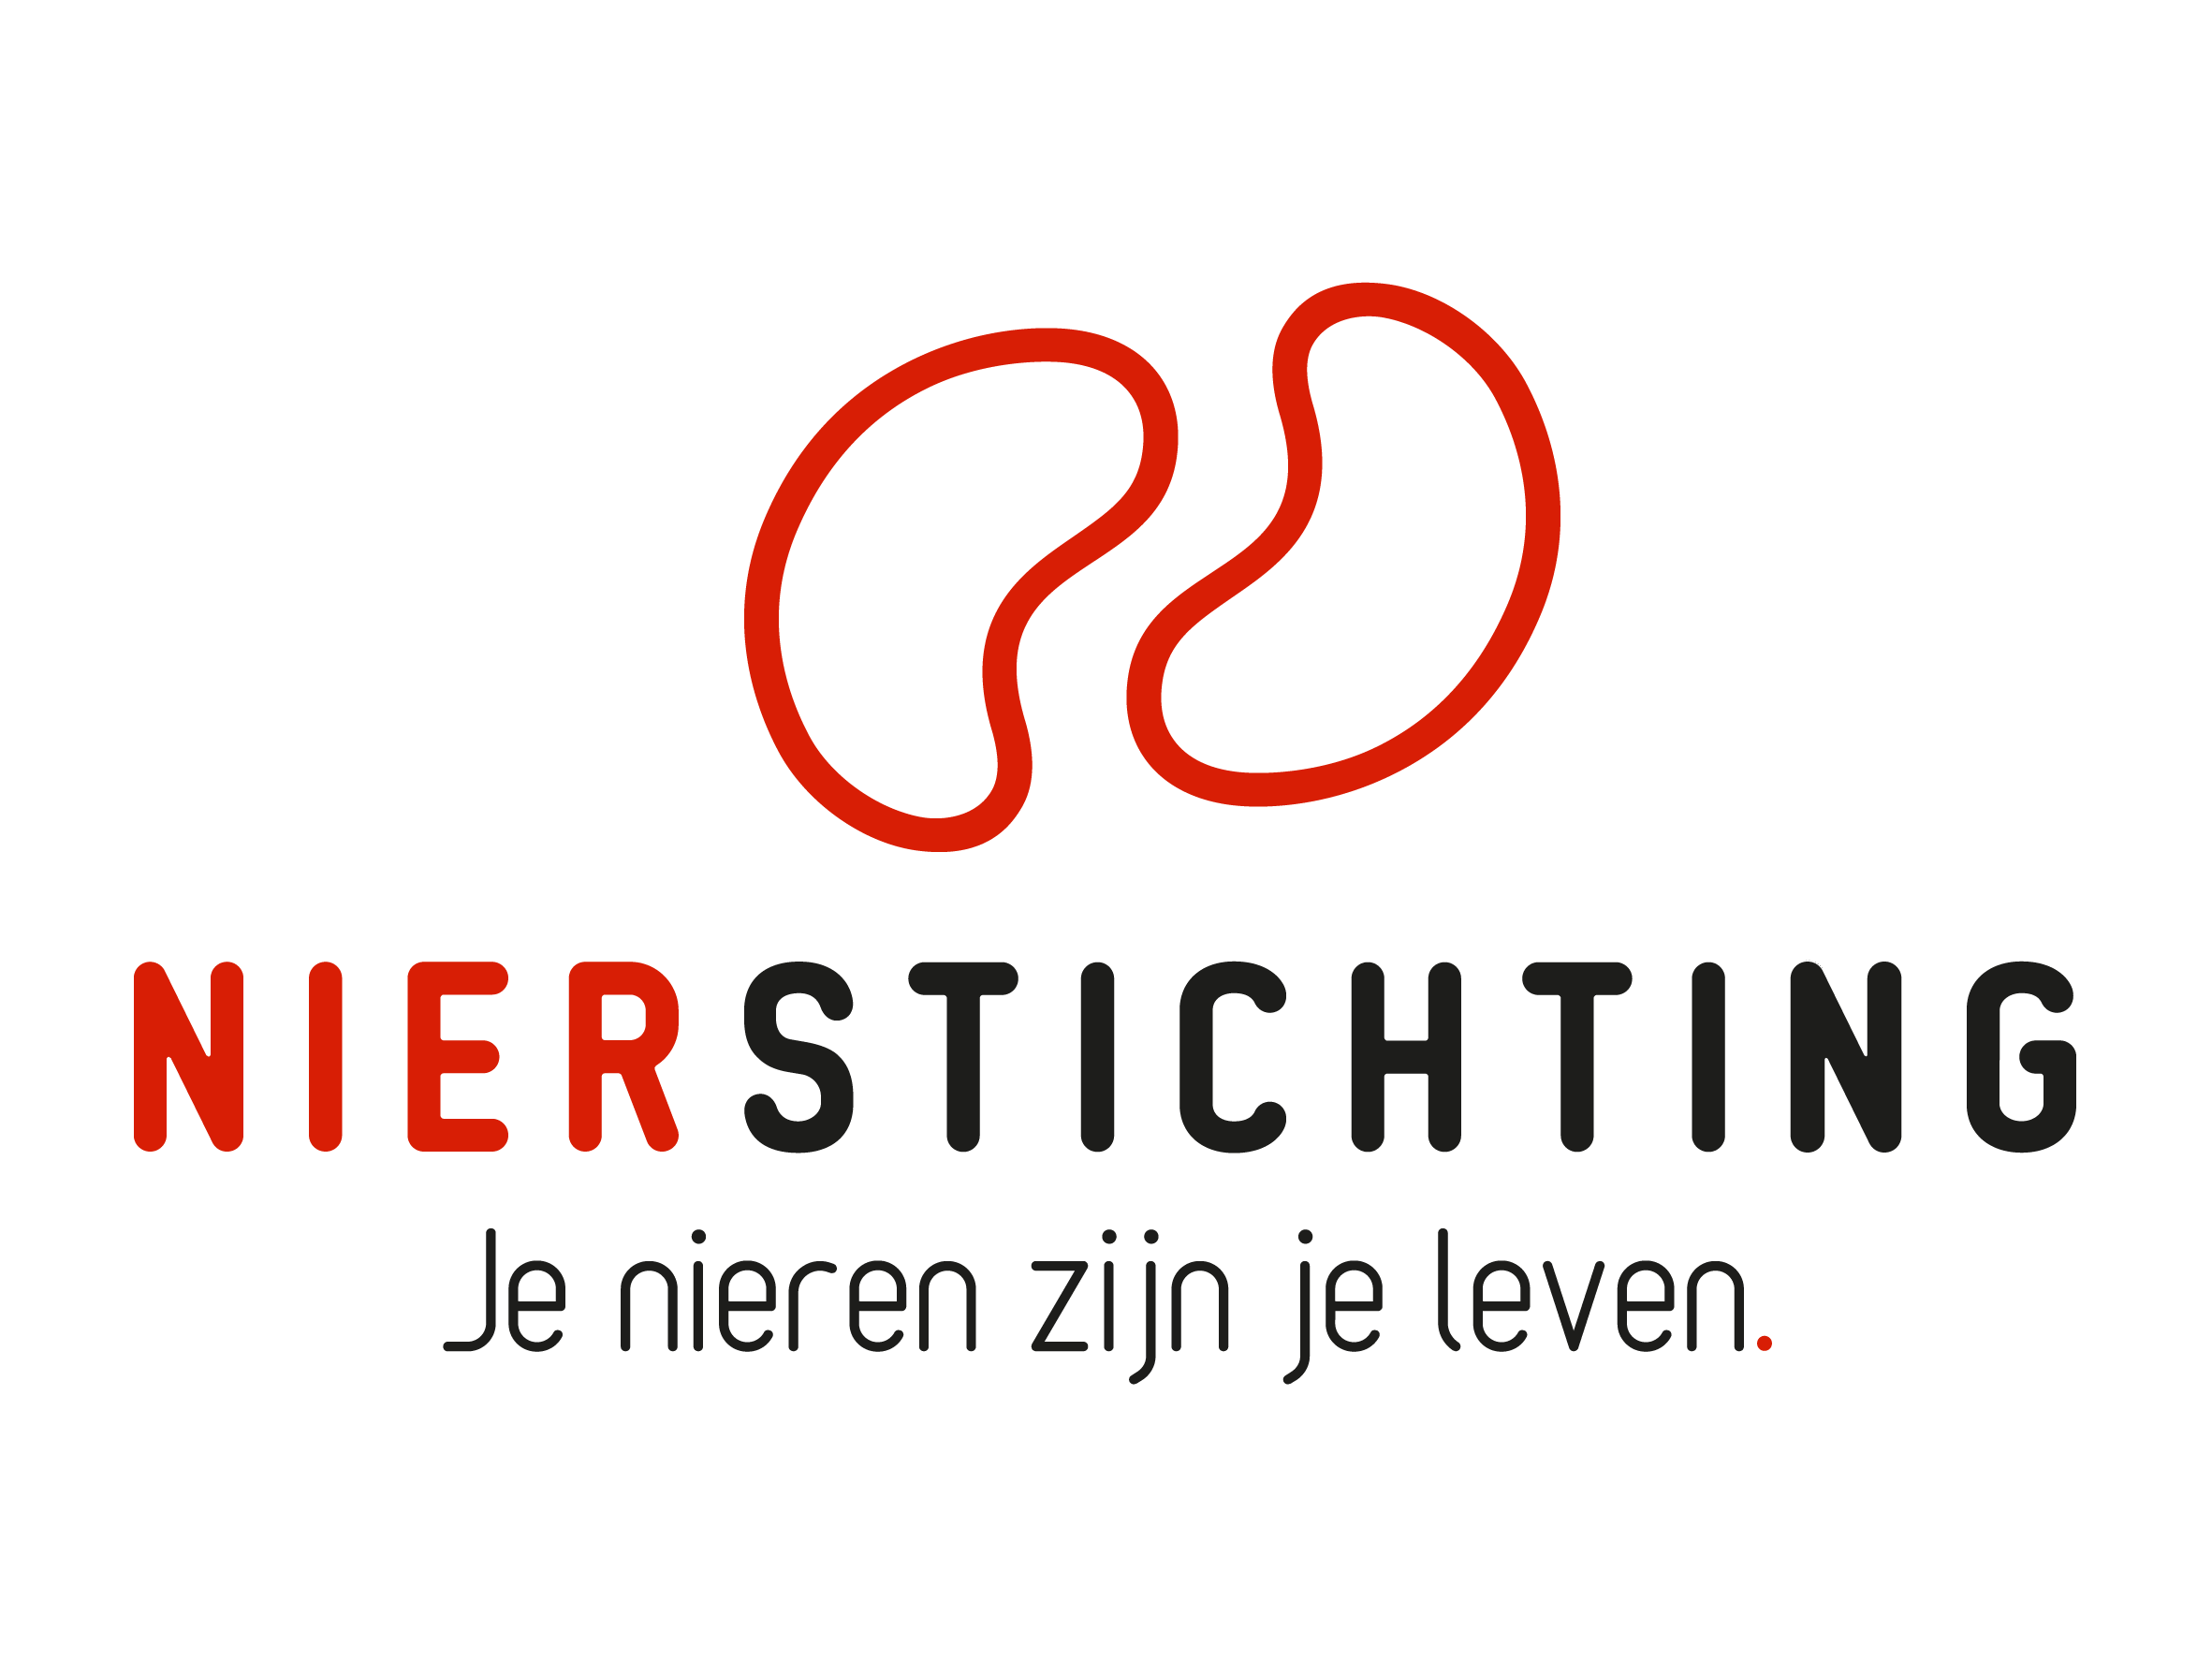
Dutch Kidney Foundation
Review form
Consortia Grant
14 Augustus 2020

Nierstichting / Dutch Kidney Foundation
+31 (0)35 697 8015
research@nierstichting.nl

Instructions for completing and submitting this form
- Your personal details are registered in our grant management system called MIDAS. You can modify your personal details or add information via the system. This review form will be send to the applicant in anonymised form and therefore has no space for your personal details.
- Please convert the completed form in a searchable PDF file. Upload the PDF file to your digital submission form in MIDAS.

1. Project
Project code
Project title
Acronym (optional)
Applicant name

2. Review
Please assess the consortia criteria (1) and the relevance (2) and the quality of the proposed research (3). Comment in your final assessment (4) on the perceived strengths and weaknesses. Grade the proposal concerning the consortia criteria, relevance and quality on a five point scale (5, 6 and 7). More information about the criteria, and the call in general, can be found in the infosheet.

2.1. Consortia Criteria
Please provide a short assessment of the specified criteria including argumentation for the perceived strengths as well as the weaknesses.
- Consortium coherence

- Linking Basic and Applied Research with a Translational Perspective

- Strategic and International Value

2.2. Relevance
Please provide an assessment along the specified criteria including argumentation for the perceived strengths as well as the weaknesses.
- Innovative potential

- Broad impact (patients, risk groups and/or the general public as well as the impact from a scientific, clinical/preventive and societal perspective)

- Cost-benefit

- Choice of target group(s)

- Knowledge transfer, implementation and follow-up

Overall Assessment Relevance Criteria
Please provide an overall assessment considering the relevance criteria.
Add to your analysis answers to the following questions.
a. If successful, what would be the potential impact of the research program on the quality of life of kidney patients?
b. What would be the consortium's contribution to the Dutch renal research field?

2.3. Quality
Please provide an assessment along the specified criteria including argumentation for the perceived strengths as well as the weaknesses. Address the workpackages separately if relevant.
- Rationale and intervention

- Quality of the individual groups and research environment

- Work plan

- Human studies

- Animal studies

- Approach and feasibility

Overall Assessment Quality Criteria
Please provide an overall assessment considering the criteria.
Add to your analysis answers to the following questions.
a. What is the intrinsic value of the collaborative effort?
b. How does the specific expertise of the research teams fit in the proposed research?

2.4. Final Assessment
Please provide a short assessment of the perceived strengths and weaknesses of the proposal.

- Strengths

- Weaknesses

2.5. Consortia Criteria
Please give scores (X) based on your own expertise.

 | poor | fair | average | good | excellent
Consortium coherence
Linking basic and applied research with a translational perspective
Strategic and international value
Overall Applicant

2.6 Relevance
Please give scores (X) based on your own expertise.

 | poor | fair | average | good | excellent
Innovative potential
Broad impact
Cost-benefit
Choice of target group(s)
Knowledge transfer, implementation and follow-up
Overall Relevance

2.7 Quality
Please give scores (X) based on your own expertise.

 | poor | fair | average | good | excellent
Rationale and intervention
Quality of the individual groups and research environment
Work plan
Human studies
Animal studies
Approach and feasibility
Overall Quality

