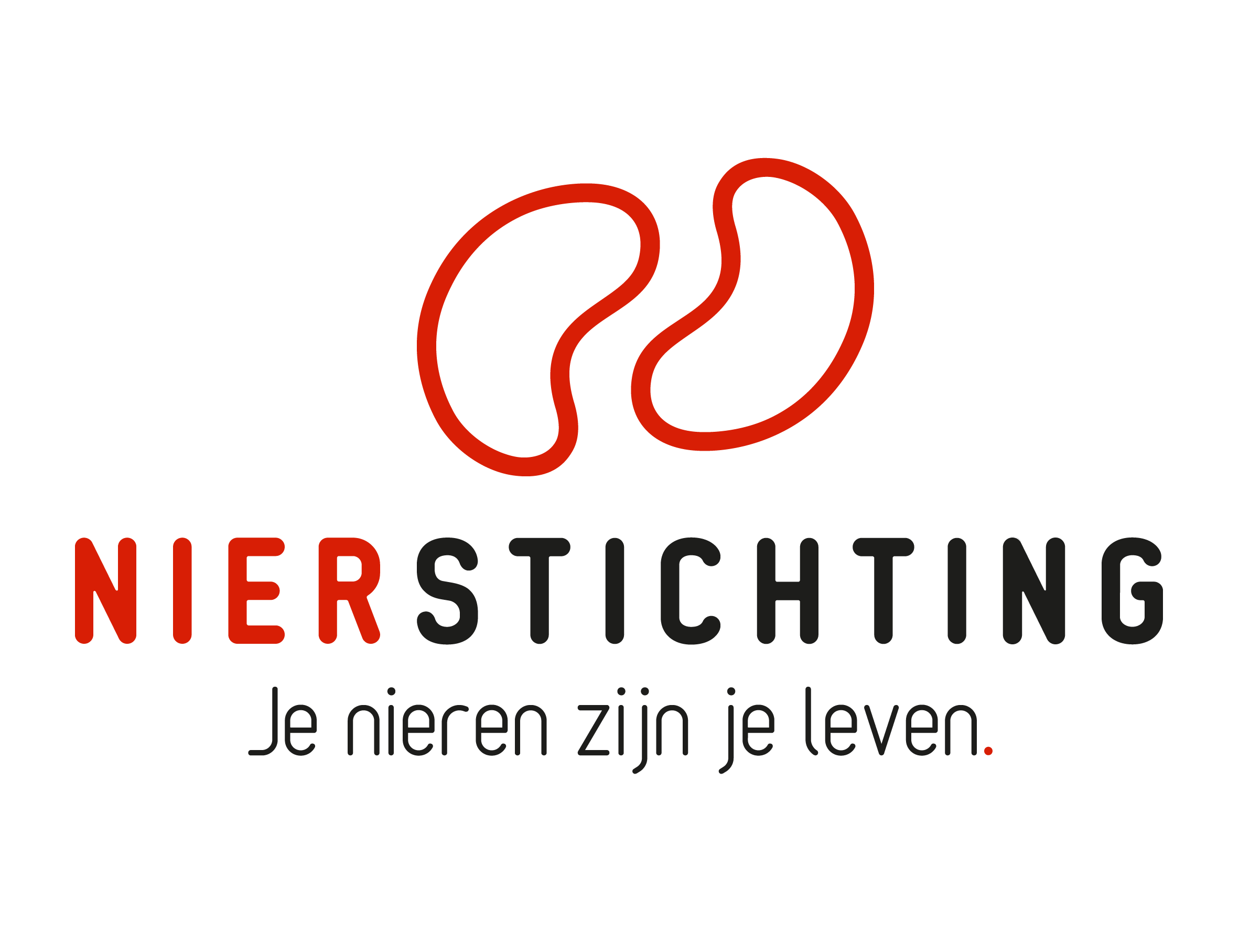
Dutch Kidney Foundation
Summary Review Form
Consortia Grant
17 Augustus 2020

Nierstichting / Dutch Kidney Foundation
+31 (0)35 697 8015
research@nierstichting.nl

Instructions for completing and submitting this form
- This form is for the summarizing assessments by the Scientific Advisory Board using the supplied international reviews, patient reviews and rebuttal.
- Your personal details are registered in our grant management system called MIDAS. You can modify your personal details or add information via the system. This review form will be send to the applicant in anonymised form and therefore has no space for your personal details.
- Please convert the completed form, including electronic signatures, in a searchable PDF file. Upload the PDF file to your digital submission form in MIDAS.

1. Project
Project code
Project title
Acronym (optional)
Applicant name

2. Quality of the Reviews
Review | insufficient | sufficient | good | very good
1
2
3
Patient review
Please add any further explanation below.

3. Quality of the Rebuttal
 | insufficient | sufficient | good | very good
Rebuttal
Please add any further explanation below.

4. Scientific Perspective
Please assess the consortia criteria (1) and the relevance (2) and the quality of the proposed research (3) from the scientific perspective using the international reviews and rebuttal. Arguments from your own expertise can be added. More information about the criteria, and the call in general, can be found in the infosheet.

4.1. Consortia Criteria
Please provide an assessment along the specified criteria including argumentation for the perceived strengths as well as the weaknesses.
- Consortium coherence

- Linking Basic and Applied Research with a Translational Perspective

- Strategic and International Value

4.2. Relevance
Please provide an assessment along the specified criteria including argumentation for the perceived strengths as well as the weaknesses.
- Innovative potential

- Broad impact (patients, risk groups and/or the general public as well as the impact from a scientific, clinical/preventive and societal perspective)

- Cost-benefit

- Choice of target group(s)

- Knowledge transfer, implementation and follow-up

4.3. Quality
Please provide an assessment along the specified criteria including argumentation for the perceived strengths as well as the weaknesses.
- Rationale and intervention

- Quality of the individual groups and research environment

- Work plan

- Human studies

- Animal studies

- Approach and feasibility

5. Patient Perspective
Please assess the proposed research from the patient perspective using the patient review and rebuttal. Please provide an assessment along the specified criteria.
- Relevance for (future) patients / Relevantie voor (toekomstige) patiënten

- Patient reported outcome measures / Patiëntgerichte uitkomstmaten

- Feasibility and Risks / Haalbaarheid en risico’s

- Information and Support / Informatie en begeleiding

- Patient Participation / Patiëntenparticipatie (anders dan deelnemen aan de studie)

- Communication of results / Communicatie van resultaten

6. Conclusions and Recommendation
Please provide a short assessment of the most important perceived strengths and weaknesses of the proposal. Also add a summarizing conclusion and recommendation.
- Strengths

- Weaknesses

- Conclusion

- Recommendation

7. Summary Tables

7.1 Scientific perspective
Please give summarizing scores (X) based on the international reviews, the rebuttal and your own expertise. Scores from the international reviews are indicated as R1, R2 etc.

Consortia Criteria
Consortium coherence | poor | fair | average | very good | excellent
Linking basic and applied research with a translational perspective
Strategic and international value
Overall Applicant

Relevance
 | poor | fair | average | very good | excellent
Innovative potential
Broad impact
Cost-benefit
Choice of target group(s)
Knowledge transfer, implementation and follow-up
Overall Relevance

Quality
 | poor | fair | average | very good | excellent
Rationale and intervention
Quality of the individual groups and research environment
Work plan
Human studies
Animal studies
Approach and feasibility
Overall Quality

7.2 Patient perspective
Please accept the scores of the patient review.
 | poor | fair | average | very good | excellent
Relevance
Quality
Overall score

7.3 Overall score
Provide an overall score for the proposal taking the scientific and patient perspective into account.
 | poor | fair | average | very good | excellent
Overall score of the proposal

